

**António Cruz** (140129)**, Cátia Brás** (120093)**, Ricardo Kayseller** (95813)

**Advanced Topics in Deep Learning**

MINI-PROJECT 02

DEEP REINFORCEMENT LEARNING

**DQN and PPO in LUnarLander v3**

**TAAP**

Table of Contents

DQN & PPO Multi-Seed Training with Checkpointing & Best-Model Selection 3

DQN & PPO Multi-Seed Report (Best Model Selection) 50

Per-Algorithm Results 54

Cross-Algorithm Comparison 59

Statistical Significance 64

Baseline Comparison 66

Agent Behavior Analysis 69

GIF Visualizations 74

Appendix: Experimental Setup 76

Environment Details 76

# DQN & PPO Multi-Seed Training with Checkpointing & Best-Model Selection

This notebook trains both DQN and PPO across multiple seeds, with: - **Periodic checkpoints** saved every N episodes - **Best-model tracking** using a combined metric (mean reward - std reward) - **Timestamped run folders** for organized model storage

Evaluates each model and produces per-algorithm, per-seed, and aggregated comparison charts.

import os, sys, random, time  
from datetime import datetime  
from typing import Callable  
  
import numpy as np  
import pandas as pd  
import torch  
import matplotlib.pyplot as plt  
  
import gymnasium as gym  
from stable_baselines3 import DQN, PPO  
from stable_baselines3.common.evaluation import evaluate_policy  
from stable_baselines3.common.vec_env import DummyVecEnv  
from stable_baselines3.common.callbacks import BaseCallback, EvalCallback, CallbackList  
from stable_baselines3.common.monitor import Monitor  
  
import imageio  
from IPython.display import Image, display

# Global Configuration  
  
SEED_LIST = [42, 123, 999]  
  
ALGORITHM_MAP = {  
 "dqn": DQN,  
 "ppo": PPO,  
}  
  
NOTEBOOK_DIR = os.path.dirname(os.path.abspath("__file__"))  
GYMNASIUM_MODEL = "LunarLander-v3"  
MLP_POLICY = "MlpPolicy"  
  
WIND_ENABLED = False  
  
TOTAL_TIMESTEPS = 1_500_000  
EVALUATION_EPISODES = 20  
  
# Update live stats and plots every N episodes  
CHART_UPDATE_FREQ = 10  
  
# Save a training checkpoint every N episodes  
CHECKPOINT_FREQ_EPISODES = 100  
  
# EvalCallback: evaluate the model every N timesteps  
EVAL_FREQ_TIMESTEPS = 25_000  
  
# EvalCallback: number of episodes per evaluation  
EVAL_N_EPISODES = 20  
  
# Solved threshold: only prefer models with mean reward >= this value  
SOLVED_THRESHOLD = 200  
  
DEVICE = "cpu"  
  
  
def linear_schedule(initial_value: float) -> Callable[[float], float]:  
 """  
 Linear learning rate schedule.  
 """  
 def func(progress_remaining: float) -> float:  
 """  
 Progress decreases from 1 (beginning) to 0 (end)  
 """  
 return progress_remaining * initial_value  
 return func  
  
  
# Per-algorithm hyperparameters  
ALGO_PARAMS = {  
 "dqn": {  
 "policy": MLP_POLICY,  
   
 # Linear Schedule allows weights to settle perfectly at the end  
 "learning_rate": linear_schedule(6.3e-4),   
   
 "learning_starts": 50_000,  
   
 # Massive buffer prevents forgetting recovery maneuvers  
 "buffer_size": 750_000,   
 "batch_size": 128,  
 "gamma": 0.99,  
   
 "exploration_fraction": 0.12,   
   
 # High final epsilon forces the agent to keep learning recoveries  
 "exploration_final_eps": 0.1,   
   
 # Standard Zoo update mechanics  
 "target_update_interval": 250,   
 "train_freq": 4,  
 # Takes 4 gradient updates every 4 env steps  
 "gradient_steps": 4,  
   
 "policy_kwargs": dict(net_arch=[256, 256]),  
 "device": DEVICE,  
 },  
 "ppo": {  
 "learning_rate": 2.5e-4,  
 "n_steps": 2048,  
 "batch_size": 64,  
 "n_epochs": 10,  
 "gamma": 0.999,  
 "gae_lambda": 0.95,  
 "ent_coef": 0.01,  
 "clip_range": 0.2,  
 },  
}  
  
print(f"Algorithms: {list(ALGORITHM_MAP.keys())}")  
print(f"Seeds: {SEED_LIST}")  
print(f"Wind enabled: {WIND_ENABLED}")  
print(f"Total timesteps per seed: {TOTAL_TIMESTEPS:,}")  
print(f"Evaluation episodes per seed: {EVALUATION_EPISODES}")  
print(f"Chart update frequency: every {CHART_UPDATE_FREQ} episodes")  
print(f"Checkpoint frequency: every {CHECKPOINT_FREQ_EPISODES} episodes")  
print(f"Eval callback frequency: every {EVAL_FREQ_TIMESTEPS:,} timesteps ({EVAL_N_EPISODES} episodes)")  
print(f"Solved threshold: {SOLVED_THRESHOLD}")  
print(f"Device: {DEVICE}")

Algorithms: ['dqn', 'ppo']  
Seeds: [42, 123, 999]  
Wind enabled: False  
Total timesteps per seed: 1,500,000  
Evaluation episodes per seed: 20  
Chart update frequency: every 10 episodes  
Checkpoint frequency: every 100 episodes  
Eval callback frequency: every 25,000 timesteps (20 episodes)  
Solved threshold: 200  
Device: cpu

print("Python:", sys.version.split()[0])  
print("PyTorch:", torch.__version__)  
print("Device:", DEVICE)  
print("CUDA:", torch.version.cuda if torch.cuda.is_available() else "None")

Python: 3.12.3  
PyTorch: 2.10.0+cu130  
Device: cpu  
CUDA: 13.0

# Environment inspection (run once)  
env_tmp = gym.make(GYMNASIUM_MODEL)  
  
print("Observation space:", env_tmp.observation_space)  
print("Action space:", env_tmp.action_space)  
  
obs, info = env_tmp.reset()  
print("Initial observation:", obs)  
  
env_tmp.close()

Observation space: Box([ -2.5 -2.5 -10. -10. -6.2831855 -10.  
 -0. -0. ], [ 2.5 2.5 10. 10. 6.2831855 10.  
 1. 1. ], (8,), float32)  
Action space: Discrete(4)  
Initial observation: [ 0.00419035 1.4124277 0.42442602 0.06699768 -0.00484882 -0.0961388  
 0. 0. ]

class DQNLoggingCallback(BaseCallback):  
  
 def __init__(self, checkpoint_path=None, verbose: int = 0):  
 super().__init__(verbose)  
 self.checkpoint_path = checkpoint_path  
 self.episode_rewards = []  
 self.episode_lengths = []  
 self.value_loss = []  
 self.entropy = []  
 self.mean_q_values = [] # Track Q-value overestimation  
 self.gradient_updates = 0 # Count gradient updates  
  
 self._current_reward = 0.0  
 self._current_length = 0  
 self._plot_handle = None  
 self._stats_handle = None  
 self._checkpoint_handle = None  
  
 def _on_step(self) -> bool:  
 rewards = self.locals.get("rewards")  
 dones = self.locals.get("dones")  
  
 if rewards is not None and dones is not None:  
 reward = rewards[0]  
 done = dones[0]  
  
 self._current_reward += float(reward)  
 self._current_length += 1  
  
 if done:  
 self.episode_rewards.append(self._current_reward)  
 self.episode_lengths.append(self._current_length)  
 ep = len(self.episode_rewards)  
  
 # Periodic checkpoint  
 if self.checkpoint_path and ep % CHECKPOINT_FREQ_EPISODES == 0:  
 ckpt_path = os.path.join(self.checkpoint_path, f"checkpoint_ep{ep}")  
 self.model.save(ckpt_path)  
 ckpt_text = f"[Checkpoint] Episode {ep} saved"  
 if self._checkpoint_handle is None:  
 self._checkpoint_handle = display(ckpt_text, display_id=True)  
 else:  
 self._checkpoint_handle.update(ckpt_text)  
  
 if ep % CHART_UPDATE_FREQ == 0:  
 recent = np.array(self.episode_rewards[-50:])  
 stats_text = (  
 f'Episode {ep} | Last {len(recent)} Ep \u2014 '  
 f'Mean: {np.mean(recent):.1f} | Std: {np.std(recent):.1f} | '  
 f'Min: {np.min(recent):.1f} | Max: {np.max(recent):.1f} | '  
 f'Success: {(recent >= 200).sum() / len(recent) * 100:.0f}%'  
 )  
 if self._stats_handle is None:  
 self._stats_handle = display(stats_text, display_id=True)  
 else:  
 self._stats_handle.update(stats_text)  
  
 if ep % CHART_UPDATE_FREQ == 0:  
 fig, (ax1, ax2) = plt.subplots(1, 2, figsize=(14, 4))  
  
 ax1.plot(self.episode_rewards, alpha=0.3, color='gray')  
 window = min(50, len(self.episode_rewards))  
 rolling = pd.Series(self.episode_rewards).rolling(window).mean()  
 ax1.plot(rolling, color='blue', linewidth=2)  
 ax1.axhline(y=200, color='red', linestyle='--')  
 ax1.set_title(f'Episode Reward \u2014 Ep {ep}')  
 ax1.set_xlabel('Episode')  
 ax1.set_ylabel('Reward')  
 ax1.grid(True, alpha=0.3)  
  
 if self.value_loss:  
 ax2.plot(self.value_loss, color='green', alpha=0.7)  
 ax2.set_title('Value Loss')  
 ax2.set_xlabel('Rollout')  
 ax2.set_ylabel('Loss')  
 ax2.grid(True, alpha=0.3)  
  
 plt.tight_layout()  
  
 if self._plot_handle is None:  
 self._plot_handle = display(fig, display_id=True)  
 else:  
 self._plot_handle.update(fig)  
 plt.close(fig)  
  
 self._current_reward = 0.0  
 self._current_length = 0  
  
 return True  
  
 def _on_rollout_end(self) -> None:  
 logger_data = self.model.logger.name_to_value  
 if "train/loss" in logger_data:  
 self.value_loss.append(logger_data["train/loss"])  
 if "rollout/exploration_rate" in logger_data:  
 self.entropy.append(logger_data["rollout/exploration_rate"])  
 if "train/n_updates" in logger_data:  
 self.gradient_updates = int(logger_data["train/n_updates"])  
  
 # Sample Q-values from current observation to track overestimation  
 try:  
 obs = self.locals.get("new_obs")  
 if obs is not None:  
 obs_tensor = torch.as_tensor(obs, device=self.model.device).float()  
 dqn_model: DQN = self.model # type: ignore[assignment]  
 with torch.no_grad():  
 q_values = dqn_model.q_net(obs_tensor)  
 self.mean_q_values.append(float(q_values.max(dim=1).values.mean()))  
 except Exception:  
 pass  
  
  
class PPOLoggingCallback(BaseCallback):  
 def __init__(self, checkpoint_path=None, verbose: int = 0):  
 super().__init__(verbose)  
 self.checkpoint_path = checkpoint_path  
 self.episode_rewards = []  
 self.episode_lengths = []  
 self.policy_loss = []  
 self.value_loss = []  
 self.entropy = []  
 self.clip_fraction = [] # PPO stability: fraction of clipped updates  
 self.approx_kl = [] # PPO stability: KL divergence  
 self.explained_variance = [] # PPO stability: value function quality  
 self.gradient_updates = 0 # Count gradient updates  
  
 self._current_rewards: np.ndarray = np.array([])  
 self._current_lengths: np.ndarray = np.array([])  
 self._plot_handle = None  
 self._stats_handle = None  
 self._checkpoint_handle = None  
  
 def _on_training_start(self) -> None:  
 n_envs = self.training_env.num_envs  
 self._current_rewards = np.zeros(n_envs, dtype=np.float32)  
 self._current_lengths = np.zeros(n_envs, dtype=np.int32)  
  
 def _on_step(self) -> bool:  
 rewards = self.locals.get("rewards")  
 dones = self.locals.get("dones")  
  
 if rewards is not None and dones is not None:  
 self._current_rewards += rewards  
 self._current_lengths += 1  
  
 for i, done in enumerate(dones):  
 if done:  
 self.episode_rewards.append(float(self._current_rewards[i]))  
 self.episode_lengths.append(int(self._current_lengths[i]))  
 ep = len(self.episode_rewards)  
  
 # Periodic checkpoint  
 if self.checkpoint_path and ep % CHECKPOINT_FREQ_EPISODES == 0:  
 ckpt_path = os.path.join(self.checkpoint_path, f"checkpoint_ep{ep}")  
 self.model.save(ckpt_path)  
 ckpt_text = f"[Checkpoint] Episode {ep} saved"  
 if self._checkpoint_handle is None:  
 self._checkpoint_handle = display(ckpt_text, display_id=True)  
 else:  
 self._checkpoint_handle.update(ckpt_text)  
  
 if ep % CHART_UPDATE_FREQ == 0:  
 recent = np.array(self.episode_rewards[-50:])  
 stats_text = (  
 f'Episode {ep} | Last {len(recent)} Ep \u2014 '  
 f'Mean: {np.mean(recent):.1f} | Std: {np.std(recent):.1f} | '  
 f'Min: {np.min(recent):.1f} | Max: {np.max(recent):.1f} | '  
 f'Success: {(recent >= 200).sum() / len(recent) * 100:.0f}%'  
 )  
 if self._stats_handle is None:  
 self._stats_handle = display(stats_text, display_id=True)  
 else:  
 self._stats_handle.update(stats_text)  
  
 if ep % CHART_UPDATE_FREQ == 0:  
 fig, (ax1, ax2) = plt.subplots(1, 2, figsize=(14, 4))  
  
 ax1.plot(self.episode_rewards, alpha=0.3, color='gray')  
 window = min(50, len(self.episode_rewards))  
 rolling = pd.Series(self.episode_rewards).rolling(window).mean()  
 ax1.plot(rolling, color='blue', linewidth=2)  
 ax1.axhline(y=200, color='red', linestyle='--')  
 ax1.set_title(f'Episode Reward \u2014 Ep {ep}')  
 ax1.set_xlabel('Episode')  
 ax1.set_ylabel('Reward')  
 ax1.grid(True, alpha=0.3)  
  
 if self.value_loss:  
 ax2.plot(self.value_loss, color='green', alpha=0.7)  
 ax2.set_title('Value Loss')  
 ax2.set_xlabel('Rollout')  
 ax2.set_ylabel('Loss')  
 ax2.grid(True, alpha=0.3)  
  
 plt.tight_layout()  
  
 if self._plot_handle is None:  
 self._plot_handle = display(fig, display_id=True)  
 else:  
 self._plot_handle.update(fig)  
 plt.close(fig)  
  
 self._current_rewards[i] = 0  
 self._current_lengths[i] = 0  
 return True  
  
 def _on_rollout_end(self) -> None:  
 logger_data = self.model.logger.name_to_value  
 if "train/policy_gradient_loss" in logger_data:  
 self.policy_loss.append(logger_data["train/policy_gradient_loss"])  
 if "train/value_loss" in logger_data:  
 self.value_loss.append(logger_data["train/value_loss"])  
 if "train/entropy_loss" in logger_data:  
 self.entropy.append(-logger_data["train/entropy_loss"])  
 if "train/clip_fraction" in logger_data:  
 self.clip_fraction.append(logger_data["train/clip_fraction"])  
 if "train/approx_kl" in logger_data:  
 self.approx_kl.append(logger_data["train/approx_kl"])  
 if "train/explained_variance" in logger_data:  
 self.explained_variance.append(logger_data["train/explained_variance"])  
 if "train/n_updates" in logger_data:  
 self.gradient_updates = int(logger_data["train/n_updates"])  
  
  
class CombinedMetricEvalCallback(EvalCallback):  
 """  
 Custom EvalCallback that selects the best model using a combined metric:  
 score = mean_reward - std_reward  
 This favors models that are both high-performing and consistent.  
  
 Two-tier selection with solved gate:  
 - Once any evaluation has mean_reward >= SOLVED_THRESHOLD, only solved  
 models can replace the current best (unsolved fallbacks are discarded).  
 - Before any model solves, the overall best score is tracked as fallback.  
 """  
  
 def __init__(self, *args, **kwargs):  
 super().__init__(*args, **kwargs)  
 self.best_combined_score = -np.inf  
 self.best_std_reward = np.inf  
 self.best_success_rate = 0.0  
 self.best_timestep = 0  
 self._any_solved = False  
 self._eval_handle = None  
  
 def _on_step(self) -> bool:  
 continue_training = True  
  
 if self.eval_freq > 0 and self.n_calls % self.eval_freq == 0:  
 episode_rewards, episode_lengths = evaluate_policy(  
 self.model,  
 self.eval_env,  
 n_eval_episodes=self.n_eval_episodes,  
 render=self.render,  
 deterministic=self.deterministic,  
 return_episode_rewards=True,  
 )  
  
 mean_reward, std_reward = np.mean(episode_rewards), np.std(episode_rewards)  
 mean_ep_length = np.mean(episode_lengths)  
 success_rate = np.sum(np.array(episode_rewards) >= 200) / len(episode_rewards) * 100 # type: ignore  
 self.last_mean_reward = mean_reward  
  
 combined_score = mean_reward - std_reward  
 is_solved = mean_reward >= SOLVED_THRESHOLD  
  
 # Two-tier best model selection:  
 # 1. If this model is solved, save if it's the first solved or has better score  
 # 2. If no model has solved yet, save the overall best as fallback  
 save_new_best = False  
 if is_solved:  
 if not self._any_solved:  
 # First solved model — always save (replaces any unsolved fallback)  
 save_new_best = True  
 self._any_solved = True  
 elif combined_score > self.best_combined_score:  
 # Better solved model  
 save_new_best = True  
 elif not self._any_solved:  
 # No solved model yet — track overall best as fallback  
 if combined_score > self.best_combined_score:  
 save_new_best = True  
  
 solved_tag = " [SOLVED]" if is_solved else ""  
 eval_text = (  
 f"Eval @ {self.num_timesteps} steps | "  
 f"Reward: {mean_reward:.2f} +/- {std_reward:.2f}{solved_tag} | "  
 f"Success: {success_rate:.0f}% | "  
 f"Score (mean-std): {combined_score:.2f} | "  
 f"Best: {self.best_combined_score:.2f}"  
 )  
  
 if save_new_best:  
 eval_text += f" >> New best model!"  
 self.best_combined_score = combined_score  
 self.best_mean_reward = mean_reward  
 self.best_std_reward = std_reward  
 self.best_success_rate = success_rate  
 self.best_timestep = self.num_timesteps  
 if self.best_model_save_path is not None:  
 self.model.save(  
 os.path.join(self.best_model_save_path, "best_model")  
 )  
  
 if self._eval_handle is None:  
 self._eval_handle = display(eval_text, display_id=True)  
 else:  
 self._eval_handle.update(eval_text)  
  
 if self.log_path is not None:  
 self.evaluations_timesteps.append(self.num_timesteps)  
 self.evaluations_results.append(episode_rewards) # type: ignore  
 self.evaluations_length.append(episode_lengths) # type: ignore  
 np.savez(  
 self.log_path,  
 timesteps=self.evaluations_timesteps,  
 results=self.evaluations_results,  
 ep_lengths=self.evaluations_length,  
 )  
  
 self.logger.record("eval/mean_reward", float(mean_reward))  
 self.logger.record("eval/std_reward", float(std_reward))  
 self.logger.record("eval/mean_ep_length", float(mean_ep_length))  
 self.logger.record("eval/combined_score", float(combined_score))  
 self.logger.record("eval/success_rate", float(success_rate))  
  
 return continue_training  
  
  
CALLBACK_MAP = {  
 "dqn": DQNLoggingCallback,  
 "ppo": PPOLoggingCallback,  
}

def set_all_seeds(seed):  
 random.seed(seed)  
 np.random.seed(seed)  
 torch.manual_seed(seed)  
 torch.use_deterministic_algorithms(True)  
 if torch.cuda.is_available():  
 torch.cuda.manual_seed(seed)  
 torch.cuda.manual_seed_all(seed)  
 torch.backends.cudnn.deterministic = True  
 torch.backends.cudnn.benchmark = False

# Training loop: algorithms x seeds  
  
training_results = {} # {algo: {seed: callback}}  
training_times = {} # {algo: {seed: seconds}}  
model_save_paths = {} # {algo: {seed: {"run_dir", "final", "best"}}}  
eval_callbacks = {} # {algo: {seed: eval_cb}} — for best-model summary table  
  
for algo_name, algo_class in ALGORITHM_MAP.items():  
  
 tb_dir = os.path.join(NOTEBOOK_DIR, "outputs_" + algo_name, "tensorboard")  
  
 training_results[algo_name] = {}  
 training_times[algo_name] = {}  
 model_save_paths[algo_name] = {}  
 eval_callbacks[algo_name] = {}  
  
 for seed in SEED_LIST:  
 print(f"\n{'='*60}")  
 print(f"{algo_name.upper()} | Seed {seed}")  
 print(f"{'='*60}\n")  
  
 # Create timestamped run directory  
 run_timestamp = datetime.now().strftime("%Y-%m-%d_%H_%M_%S")  
 run_dir = os.path.join(NOTEBOOK_DIR, "../../../models", algo_name, run_timestamp)  
 checkpoints_dir = os.path.join(run_dir, "checkpoints")  
 os.makedirs(checkpoints_dir, exist_ok=True)  
  
 set_all_seeds(seed)  
  
 def make_env(s=seed):  
 env = gym.make(GYMNASIUM_MODEL, render_mode="rgb_array", enable_wind=WIND_ENABLED)  
 env.reset(seed=s)  
 return env  
  
 env = DummyVecEnv([make_env])  
 env.seed(seed)  
  
 # Separate eval env for EvalCallback  
 def make_eval_env(s=seed):  
 e = Monitor(gym.make(GYMNASIUM_MODEL, render_mode="rgb_array", enable_wind=WIND_ENABLED))  
 e.reset(seed=s)  
 return e  
  
 eval_env = DummyVecEnv([make_eval_env])  
  
 params = {  
 "policy": MLP_POLICY,  
 "env": env,  
 "device": DEVICE,  
 "seed": seed,  
 "tensorboard_log": tb_dir,  
 **ALGO_PARAMS[algo_name],  
 }  
  
 model = algo_class(**params)  
  
 # Setup callbacks  
 logging_cb = CALLBACK_MAP[algo_name](checkpoint_path=checkpoints_dir)  
 eval_cb = CombinedMetricEvalCallback(  
 eval_env=eval_env,  
 eval_freq=EVAL_FREQ_TIMESTEPS,  
 n_eval_episodes=EVAL_N_EPISODES,  
 best_model_save_path=run_dir,  
 log_path=os.path.join(run_dir, "eval_log"),  
 deterministic=True,  
 verbose=1,  
 )  
  
 t_start = time.time()  
 model.learn(  
 total_timesteps=TOTAL_TIMESTEPS,  
 callback=CallbackList([logging_cb, eval_cb]),  
 progress_bar=True,  
 )  
 t_elapsed = time.time() - t_start  
  
 training_times[algo_name][seed] = t_elapsed  
 print(f"\nTraining time: {t_elapsed/60:.1f} min ({t_elapsed:.0f} s)")  
  
 # Save final model  
 final_path = os.path.join(run_dir, f"lab009_{algo_name}_{seed}")  
 model.save(final_path)  
 print(f"Final model: {final_path}")  
 print(f"Best model: {os.path.join(run_dir, 'best_model')}")  
 print(f"Checkpoints: {checkpoints_dir}")  
 print(  
 f"Best model stats: "  
 f"Reward: {eval_cb.best_mean_reward:.2f} +/- {eval_cb.best_std_reward:.2f} | "  
 f"Success: {eval_cb.best_success_rate:.0f}% | "  
 f"Score (mean-std): {eval_cb.best_combined_score:.2f} | "  
 f"@ {eval_cb.best_timestep:,} steps"  
 )  
  
 model_save_paths[algo_name][seed] = {  
 "run_dir": run_dir,  
 "final": final_path,  
 "best": os.path.join(run_dir, "best_model"),  
 }  
  
 training_results[algo_name][seed] = logging_cb  
 eval_callbacks[algo_name][seed] = eval_cb  
  
 env.close()  
 eval_env.close()  
  
 print(f"\n{algo_name.upper()}: All {len(SEED_LIST)} seeds trained.")  
  
# Best Model Summary Table  
print(f"\n{'='*60}")  
print("BEST MODEL SUMMARY (all algorithms x seeds)")  
print(f"{'='*60}\n")  
  
best_rows = []  
for algo_name in ALGORITHM_MAP:  
 for seed in SEED_LIST:  
 cb = eval_callbacks[algo_name][seed]  
 best_rows.append({  
 "Algorithm": algo_name.upper(),  
 "Seed": seed,  
 "Mean Reward": f"{cb.best_mean_reward:.2f}",  
 "Std Reward": f"{cb.best_std_reward:.2f}",  
 "Success": f"{cb.best_success_rate:.0f}%",  
 "Score (mean-std)": f"{cb.best_combined_score:.2f}",  
 "@ Timestep": f"{cb.best_timestep:,}",  
 })  
  
print(pd.DataFrame(best_rows).to_string(index=False))  
print(f"\nAll training complete.")

============================================================  
DQN | Seed 42  
============================================================  
  
  
  
  
Output()  
  
  
  
'Episode 5420 | Last 50 Ep — Mean: 236.2 | Std: 95.5 | Min: 15.8 | Max: 315.9 | Success: 82%'

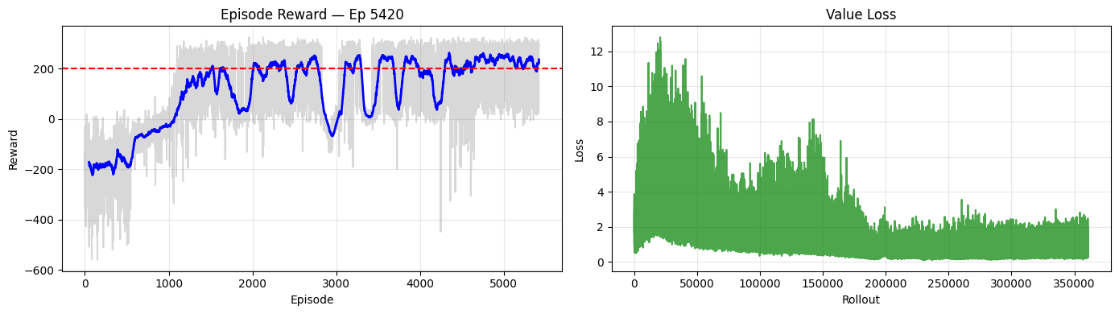

'[Checkpoint] Episode 5400 saved'  
  
  
  
'Eval @ 1500000 steps | Reward: 276.50 +/- 16.66 [SOLVED] | Success: 100% | Score (mean-std): 259.85 | Best: 266.35'

Output()  
  
  
  
'Episode 7790 | Last 50 Ep — Mean: -708.5 | Std: 349.2 | Min: -2311.8 | Max: -262.3 | Success: 0%'

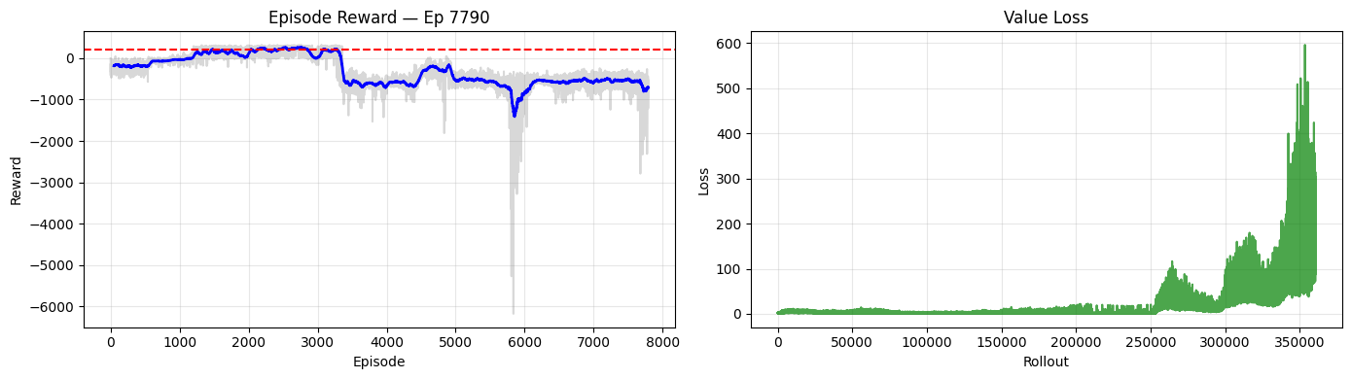

Training time: 52.4 min (3146 s)  
Final model: /home/logus/env/iscte/taap_p2/drafts/draft_01/gymnasium/../../../models/dqn/2026-02-21_20_43_20/lab009_dqn_42  
Best model: /home/logus/env/iscte/taap_p2/drafts/draft_01/gymnasium/../../../models/dqn/2026-02-21_20_43_20/best_model  
Checkpoints: /home/logus/env/iscte/taap_p2/drafts/draft_01/gymnasium/../../../models/dqn/2026-02-21_20_43_20/checkpoints  
Best model stats: Reward: 283.74 +/- 17.39 | Success: 100% | Score (mean-std): 266.35 | @ 1,425,000 steps  
  
============================================================  
DQN | Seed 123  
============================================================  
  
  
  
  
'[Checkpoint] Episode 7700 saved'  
  
  
  
'Eval @ 1500000 steps | Reward: -926.29 +/- 368.67 | Success: 0% | Score (mean-std): -1294.96 | Best: 259.82'

Output()  
  
  
  
'Episode 11860 | Last 50 Ep — Mean: -590.1 | Std: 162.5 | Min: -1082.2 | Max: -348.5 | Success: 0%'

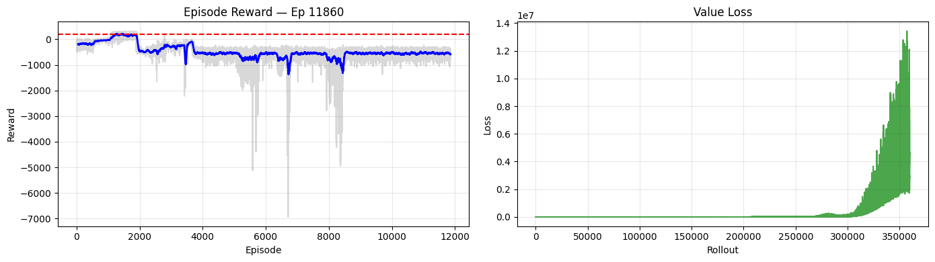

Training time: 51.5 min (3093 s)  
Final model: /home/logus/env/iscte/taap_p2/drafts/draft_01/gymnasium/../../../models/dqn/2026-02-21_21_35_46/lab009_dqn_123  
Best model: /home/logus/env/iscte/taap_p2/drafts/draft_01/gymnasium/../../../models/dqn/2026-02-21_21_35_46/best_model  
Checkpoints: /home/logus/env/iscte/taap_p2/drafts/draft_01/gymnasium/../../../models/dqn/2026-02-21_21_35_46/checkpoints  
Best model stats: Reward: 275.61 +/- 15.80 | Success: 100% | Score (mean-std): 259.82 | @ 875,000 steps  
  
============================================================  
DQN | Seed 999  
============================================================  
  
  
  
  
'[Checkpoint] Episode 11800 saved'  
  
  
  
'Eval @ 1500000 steps | Reward: -593.75 +/- 172.38 | Success: 0% | Score (mean-std): -766.14 | Best: 243.87'

Output()  
  
  
  
Training time: 50.4 min (3025 s)  
Final model: /home/logus/env/iscte/taap_p2/drafts/draft_01/gymnasium/../../../models/dqn/2026-02-21_22_27_19/lab009_dqn_999  
Best model: /home/logus/env/iscte/taap_p2/drafts/draft_01/gymnasium/../../../models/dqn/2026-02-21_22_27_19/best_model  
Checkpoints: /home/logus/env/iscte/taap_p2/drafts/draft_01/gymnasium/../../../models/dqn/2026-02-21_22_27_19/checkpoints  
Best model stats: Reward: 266.25 +/- 22.38 | Success: 100% | Score (mean-std): 243.87 | @ 550,000 steps  
  
DQN: All 3 seeds trained.  
  
============================================================  
PPO | Seed 42  
============================================================  
  
  
  
  
'Episode 4710 | Last 50 Ep — Mean: 278.3 | Std: 31.3 | Min: 146.7 | Max: 320.5 | Success: 96%'

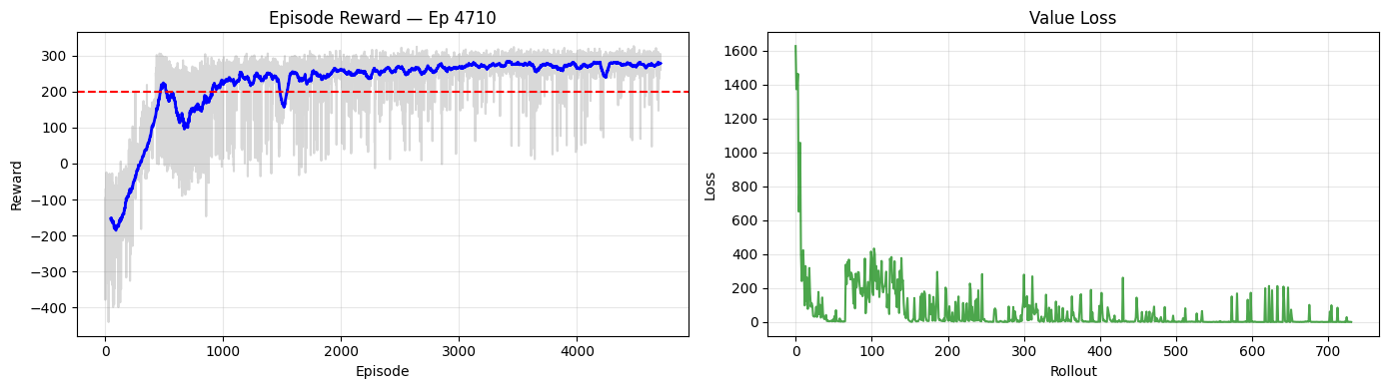

'[Checkpoint] Episode 4700 saved'  
  
  
  
'Eval @ 1500000 steps | Reward: 289.50 +/- 21.48 [SOLVED] | Success: 100% | Score (mean-std): 268.02 | Best: 266.36 >> New best model!'

Output()  
  
  
  
Training time: 21.6 min (1294 s)  
Final model: /home/logus/env/iscte/taap_p2/drafts/draft_01/gymnasium/../../../models/ppo/2026-02-21_23_17_45/lab009_ppo_42  
Best model: /home/logus/env/iscte/taap_p2/drafts/draft_01/gymnasium/../../../models/ppo/2026-02-21_23_17_45/best_model  
Checkpoints: /home/logus/env/iscte/taap_p2/drafts/draft_01/gymnasium/../../../models/ppo/2026-02-21_23_17_45/checkpoints  
Best model stats: Reward: 289.50 +/- 21.48 | Success: 100% | Score (mean-std): 268.02 | @ 1,500,000 steps  
  
============================================================  
PPO | Seed 123  
============================================================  
  
  
  
  
'Episode 3670 | Last 50 Ep — Mean: 252.4 | Std: 46.9 | Min: 56.7 | Max: 301.1 | Success: 90%'

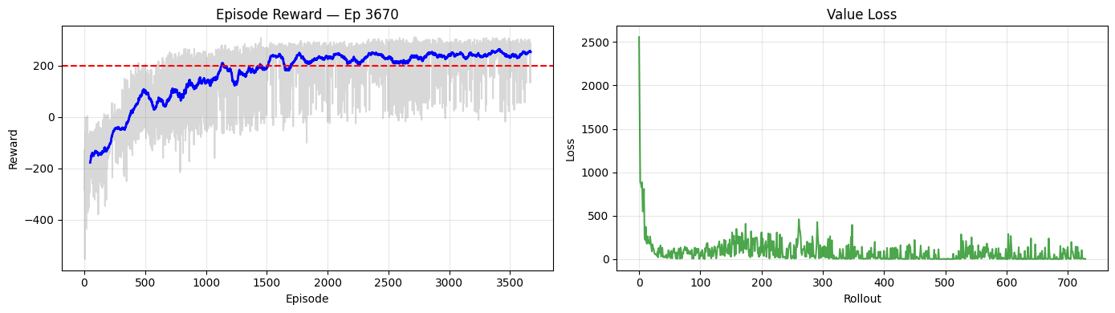

'[Checkpoint] Episode 3600 saved'  
  
  
  
'Eval @ 1500000 steps | Reward: 257.63 +/- 35.30 [SOLVED] | Success: 95% | Score (mean-std): 222.33 | Best: 249.47'

Output()  
  
  
  
Training time: 24.6 min (1475 s)  
Final model: /home/logus/env/iscte/taap_p2/drafts/draft_01/gymnasium/../../../models/ppo/2026-02-21_23_39_19/lab009_ppo_123  
Best model: /home/logus/env/iscte/taap_p2/drafts/draft_01/gymnasium/../../../models/ppo/2026-02-21_23_39_19/best_model  
Checkpoints: /home/logus/env/iscte/taap_p2/drafts/draft_01/gymnasium/../../../models/ppo/2026-02-21_23_39_19/checkpoints  
Best model stats: Reward: 267.61 +/- 18.14 | Success: 100% | Score (mean-std): 249.47 | @ 1,300,000 steps  
  
============================================================  
PPO | Seed 999  
============================================================  
  
  
  
  
'Episode 5110 | Last 50 Ep — Mean: 264.0 | Std: 47.3 | Min: 83.3 | Max: 323.9 | Success: 90%'

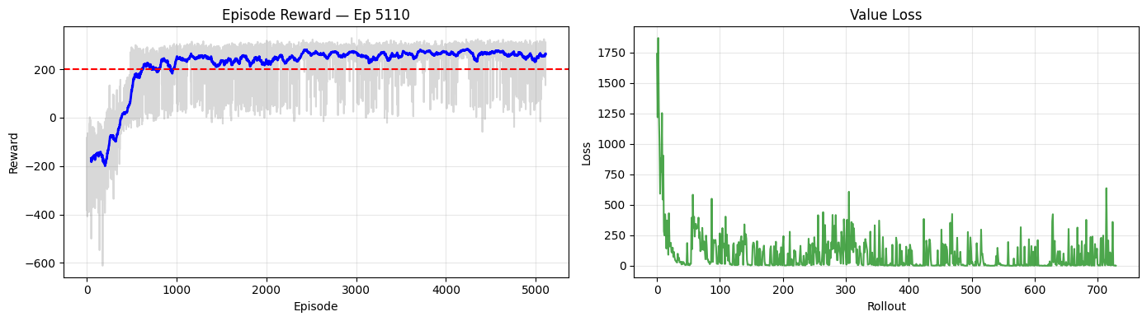

'[Checkpoint] Episode 5100 saved'  
  
  
  
'Eval @ 1500000 steps | Reward: 271.94 +/- 35.27 [SOLVED] | Success: 95% | Score (mean-std): 236.66 | Best: 266.00'

Training time: 20.6 min (1235 s)  
Final model: /home/logus/env/iscte/taap_p2/drafts/draft_01/gymnasium/../../../models/ppo/2026-02-22_00_03_53/lab009_ppo_999  
Best model: /home/logus/env/iscte/taap_p2/drafts/draft_01/gymnasium/../../../models/ppo/2026-02-22_00_03_53/best_model  
Checkpoints: /home/logus/env/iscte/taap_p2/drafts/draft_01/gymnasium/../../../models/ppo/2026-02-22_00_03_53/checkpoints  
Best model stats: Reward: 285.68 +/- 19.69 | Success: 100% | Score (mean-std): 266.00 | @ 1,175,000 steps  
  
PPO: All 3 seeds trained.  
  
============================================================  
BEST MODEL SUMMARY (all algorithms x seeds)  
============================================================  
  
Algorithm Seed Mean Reward Std Reward Success Score (mean-std) @ Timestep  
 DQN 42 283.74 17.39 100% 266.35 1,425,000  
 DQN 123 275.61 15.80 100% 259.82 875,000  
 DQN 999 266.25 22.38 100% 243.87 550,000  
 PPO 42 289.50 21.48 100% 268.02 1,500,000  
 PPO 123 267.61 18.14 100% 249.47 1,300,000  
 PPO 999 285.68 19.69 100% 266.00 1,175,000  
  
All training complete.

# Training Time Summary  
  
rows = []  
for algo_name in ALGORITHM_MAP:  
 for seed in SEED_LIST:  
 t = training_times[algo_name][seed]  
 rows.append({  
 "Algorithm": algo_name.upper(),  
 "Seed": seed,  
 "Time (s)": f"{t:.0f}",  
 "Time (min)": f"{t/60:.1f}",  
 })  
  
for algo_name in ALGORITHM_MAP:  
 times = list(training_times[algo_name].values())  
 rows.append({  
 "Algorithm": algo_name.upper(),  
 "Seed": "Mean",  
 "Time (s)": f"{np.mean(times):.0f}",  
 "Time (min)": f"{np.mean(times)/60:.1f}",  
 })  
  
print("*** TRAINING TIME SUMMARY ***")  
print(f"Timesteps per seed: {TOTAL_TIMESTEPS:,} | Device: {DEVICE}")  
print()  
print(pd.DataFrame(rows).to_string(index=False))

*** TRAINING TIME SUMMARY ***  
Timesteps per seed: 1,500,000 | Device: cpu  
  
Algorithm Seed Time (s) Time (min)  
 DQN 42 3146 52.4  
 DQN 123 3093 51.5  
 DQN 999 3025 50.4  
 PPO 42 1294 21.6  
 PPO 123 1475 24.6  
 PPO 999 1235 20.6  
 DQN Mean 3088 51.5  
 PPO Mean 1335 22.2

# Gradient Updates Summary  
# DQN: train_freq=4, gradient_steps=4 -> 4 gradient steps every 4 env steps  
# PPO: n_steps=2048, n_epochs=10, batch_size=128 -> 10 * (2048/128) = 160 updates per rollout  
  
rows = []  
for algo_name in ALGORITHM_MAP:  
 # Use the actual count from the last seed's callback  
 last_seed = SEED_LIST[-1]  
 actual_updates = training_results[algo_name][last_seed].gradient_updates  
  
 # Also compute analytically for verification  
 if algo_name == "dqn":  
 p = ALGO_PARAMS["dqn"]  
 train_freq = p.get("train_freq", 4)  
 grad_steps = p.get("gradient_steps", -1)  
 learning_starts = p.get("learning_starts", 0)  
 effective_steps = TOTAL_TIMESTEPS - learning_starts  
 steps_per_call = train_freq if grad_steps == -1 else grad_steps  
 analytical = (effective_steps // train_freq) * steps_per_call  
 else:  
 p = ALGO_PARAMS["ppo"]  
 n_steps = p.get("n_steps", 2048)  
 n_epochs = p.get("n_epochs", 10)  
 batch_size = p.get("batch_size", 128)  
 n_rollouts = TOTAL_TIMESTEPS // n_steps  
 minibatches_per_epoch = n_steps // batch_size  
 analytical = n_rollouts * n_epochs * minibatches_per_epoch  
  
 rows.append({  
 "Algorithm": algo_name.upper(),  
 "Actual (from training)": f"{actual_updates:,}",  
 "Analytical (computed)": f"{analytical:,}",  
 "Total Env Steps": f"{TOTAL_TIMESTEPS:,}",  
 "Ratio (updates/steps)": f"{actual_updates / TOTAL_TIMESTEPS:.3f}",  
 })  
  
print("*** GRADIENT UPDATES SUMMARY ***")  
print(pd.DataFrame(rows).to_string(index=False))  
print()  
print("DQN: train_freq=4, gradient_steps=4 -> 4 gradient updates per training call, called every 4 env steps")  
print(f"PPO: n_steps={ALGO_PARAMS['ppo']['n_steps']}, n_epochs={ALGO_PARAMS['ppo']['n_epochs']}, "  
 f"batch_size={ALGO_PARAMS['ppo']['batch_size']} -> "  
 f"{ALGO_PARAMS['ppo']['n_epochs'] * (ALGO_PARAMS['ppo']['n_steps'] // ALGO_PARAMS['ppo']['batch_size'])} "  
 f"updates per rollout")

*** GRADIENT UPDATES SUMMARY ***  
Algorithm Actual (from training) Analytical (computed) Total Env Steps Ratio (updates/steps)  
 DQN 1,449,996 1,450,000 1,500,000 0.967  
 PPO 7,320 234,240 1,500,000 0.005  
  
DQN: train_freq=4, gradient_steps=4 -> 4 gradient updates per training call, called every 4 env steps  
PPO: n_steps=2048, n_epochs=10, batch_size=64 -> 320 updates per rollout

# Per-Algorithm, Per-Seed: Episode Reward over Training  
  
for algo_name in ALGORITHM_MAP:  
 fig, axes = plt.subplots(1, len(SEED_LIST), figsize=(6 * len(SEED_LIST), 5), sharey=True)  
 if len(SEED_LIST) == 1:  
 axes = [axes]  
  
 for ax, seed in zip(axes, SEED_LIST):  
 ax.plot(training_results[algo_name][seed].episode_rewards, alpha=0.7)  
 ax.set_title(f"Seed {seed}")  
 ax.set_xlabel("Episode")  
 ax.grid(True, alpha=0.3)  
  
 axes[0].set_ylabel("Total Reward")  
 fig.suptitle(f"{algo_name.upper()} \u2014 Episode Reward over Training", fontsize=14)  
 plt.tight_layout()  
 plt.show()

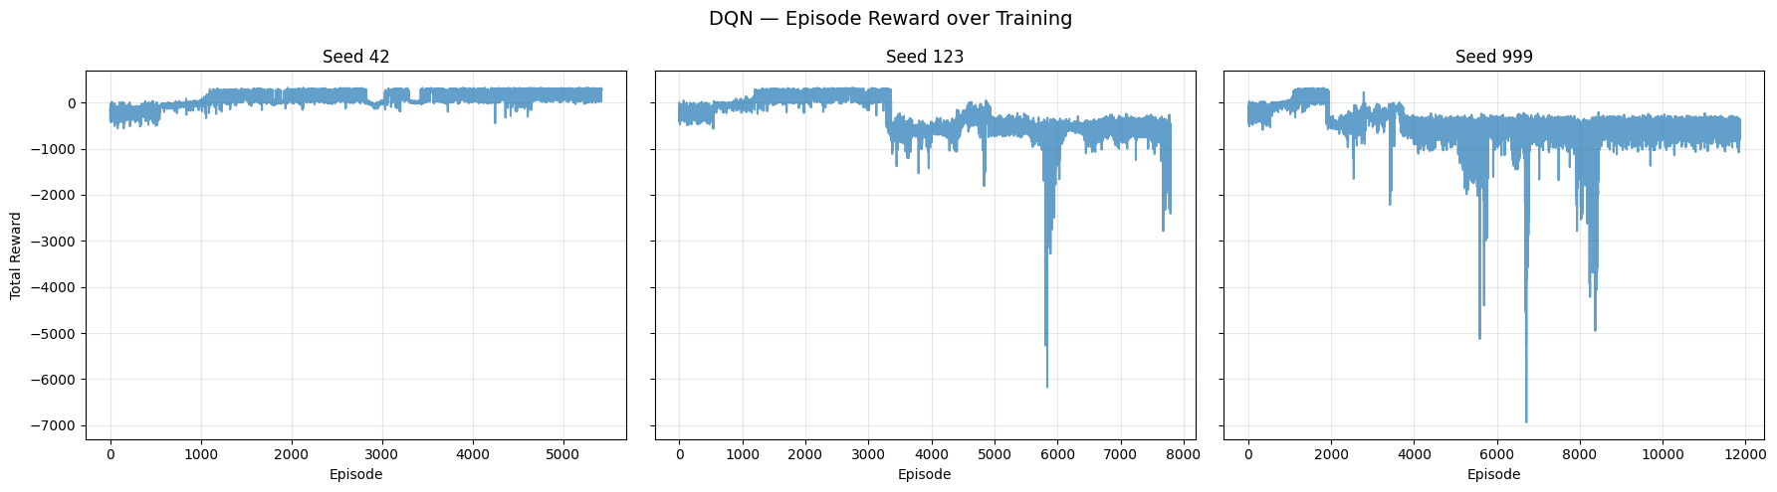

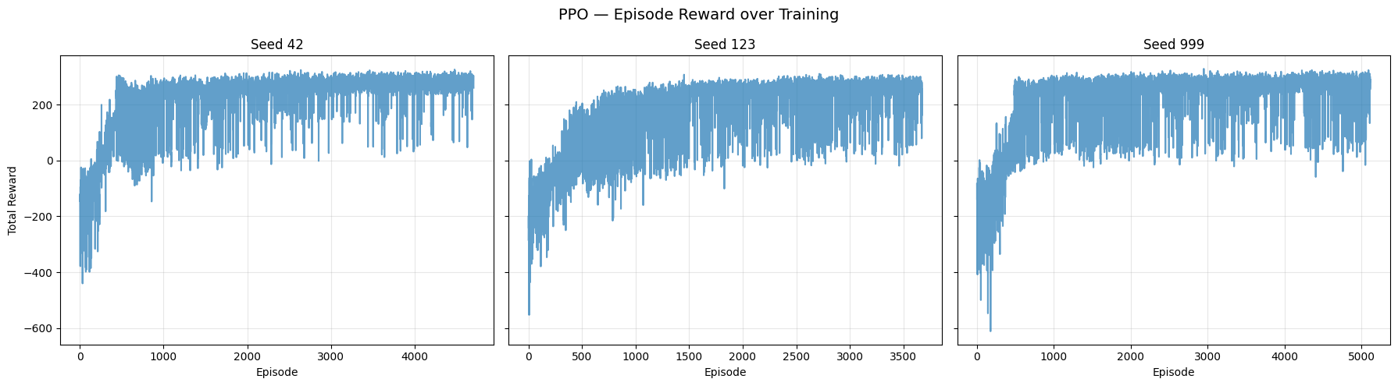

# Per-Algorithm, Per-Seed: Episode Length over Training  
  
for algo_name in ALGORITHM_MAP:  
 fig, axes = plt.subplots(1, len(SEED_LIST), figsize=(6 * len(SEED_LIST), 5), sharey=True)  
 if len(SEED_LIST) == 1:  
 axes = [axes]  
  
 for ax, seed in zip(axes, SEED_LIST):  
 ax.plot(training_results[algo_name][seed].episode_lengths, alpha=0.7, color="orange")  
 ax.set_title(f"Seed {seed}")  
 ax.set_xlabel("Episode")  
 ax.grid(True, alpha=0.3)  
  
 axes[0].set_ylabel("Number of Steps")  
 fig.suptitle(f"{algo_name.upper()} \u2014 Episode Length over Training", fontsize=14)  
 plt.tight_layout()  
 plt.show()

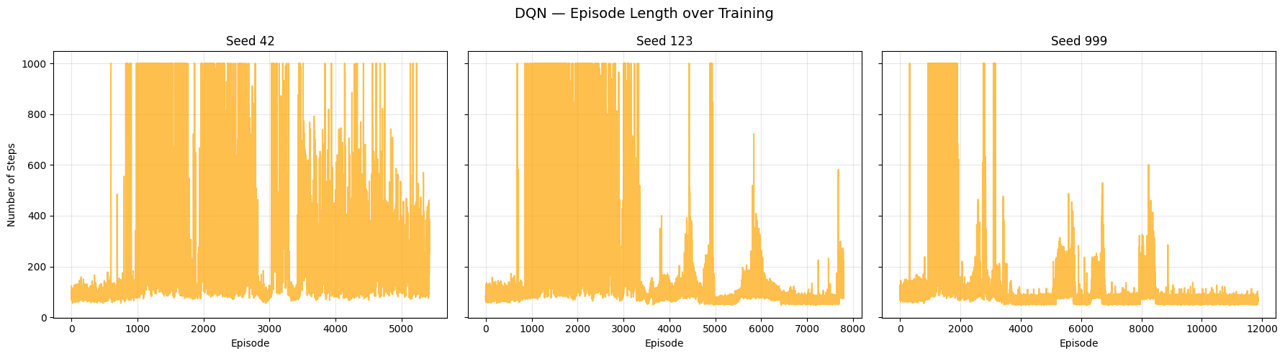

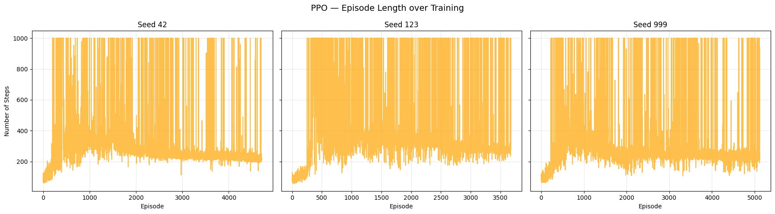

# Per-Algorithm, Per-Seed: Value Loss over Rollouts  
  
for algo_name in ALGORITHM_MAP:  
 fig, axes = plt.subplots(1, len(SEED_LIST), figsize=(6 * len(SEED_LIST), 5), sharey=True)  
 if len(SEED_LIST) == 1:  
 axes = [axes]  
  
 for ax, seed in zip(axes, SEED_LIST):  
 ax.plot(training_results[algo_name][seed].value_loss, alpha=0.7, color="green")  
 ax.set_title(f"Seed {seed}")  
 ax.set_xlabel("Rollout")  
 ax.grid(True, alpha=0.3)  
  
 axes[0].set_ylabel("Loss Value")  
 fig.suptitle(f"{algo_name.upper()} \u2014 Value Loss over Rollouts", fontsize=14)  
 plt.tight_layout()  
 plt.show()

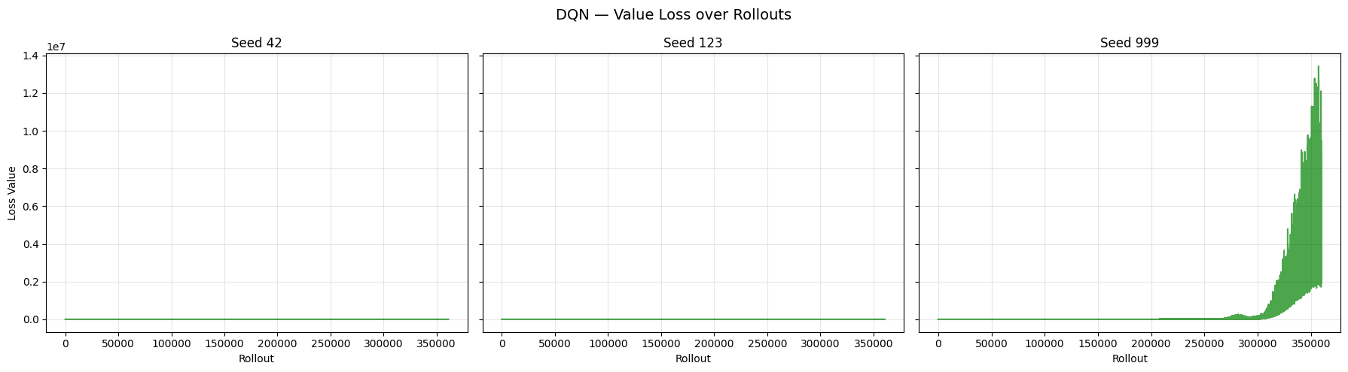

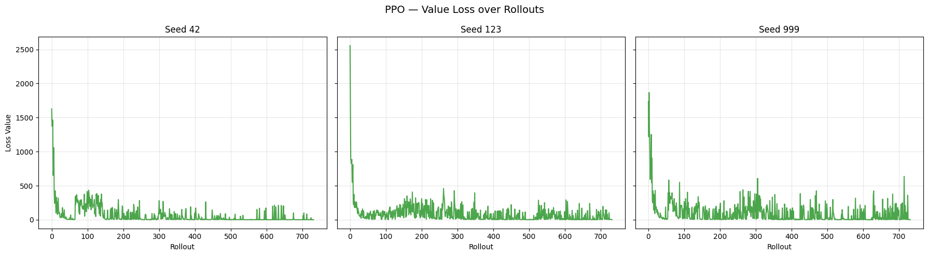

# Per-Algorithm, Per-Seed: Entropy / Exploration Rate over Rollouts  
  
entropy_labels = {"dqn": ("Epsilon", "Exploration Rate"), "ppo": ("Entropy (Positive)", "Entropy")}  
  
for algo_name in ALGORITHM_MAP:  
 ylabel, title_suffix = entropy_labels[algo_name]  
  
 fig, axes = plt.subplots(1, len(SEED_LIST), figsize=(6 * len(SEED_LIST), 5), sharey=True)  
 if len(SEED_LIST) == 1:  
 axes = [axes]  
  
 for ax, seed in zip(axes, SEED_LIST):  
 ax.plot(training_results[algo_name][seed].entropy, alpha=0.7, color="purple")  
 ax.set_title(f"Seed {seed}")  
 ax.set_xlabel("Rollout")  
 ax.grid(True, alpha=0.3)  
  
 axes[0].set_ylabel(ylabel)  
 fig.suptitle(f"{algo_name.upper()} \u2014 {title_suffix} over Rollouts", fontsize=14)  
 plt.tight_layout()  
 plt.show()

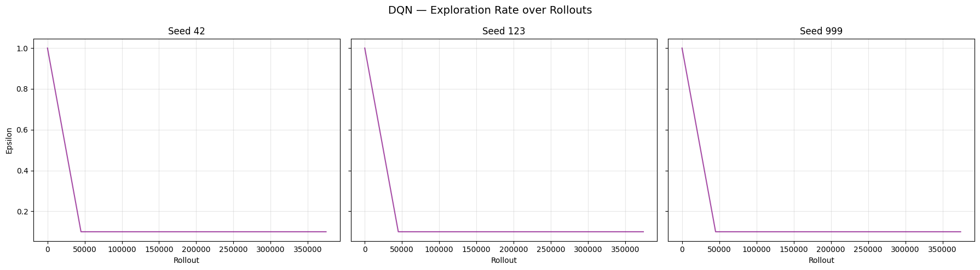

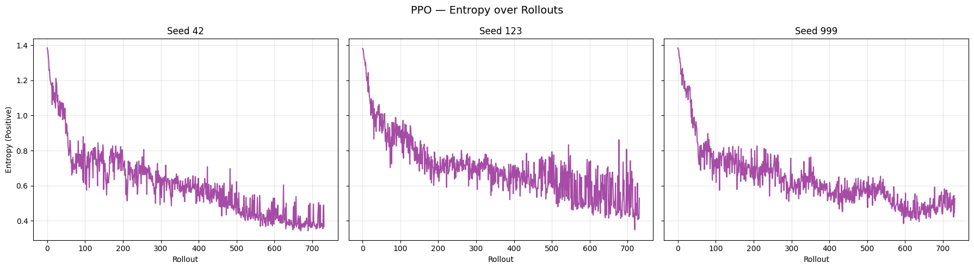

# PPO Only: Policy Loss over Rollouts  
  
fig, axes = plt.subplots(1, len(SEED_LIST), figsize=(6 * len(SEED_LIST), 5), sharey=True)  
if len(SEED_LIST) == 1:  
 axes = [axes]  
  
for ax, seed in zip(axes, SEED_LIST):  
 ax.plot(training_results["ppo"][seed].policy_loss, alpha=0.7, color="red")  
 ax.set_title(f"Seed {seed}")  
 ax.set_xlabel("Rollout")  
 ax.grid(True, alpha=0.3)  
  
axes[0].set_ylabel("Policy Loss")  
fig.suptitle("PPO \u2014 Policy Gradient Loss over Rollouts", fontsize=14)  
plt.tight_layout()  
plt.show()

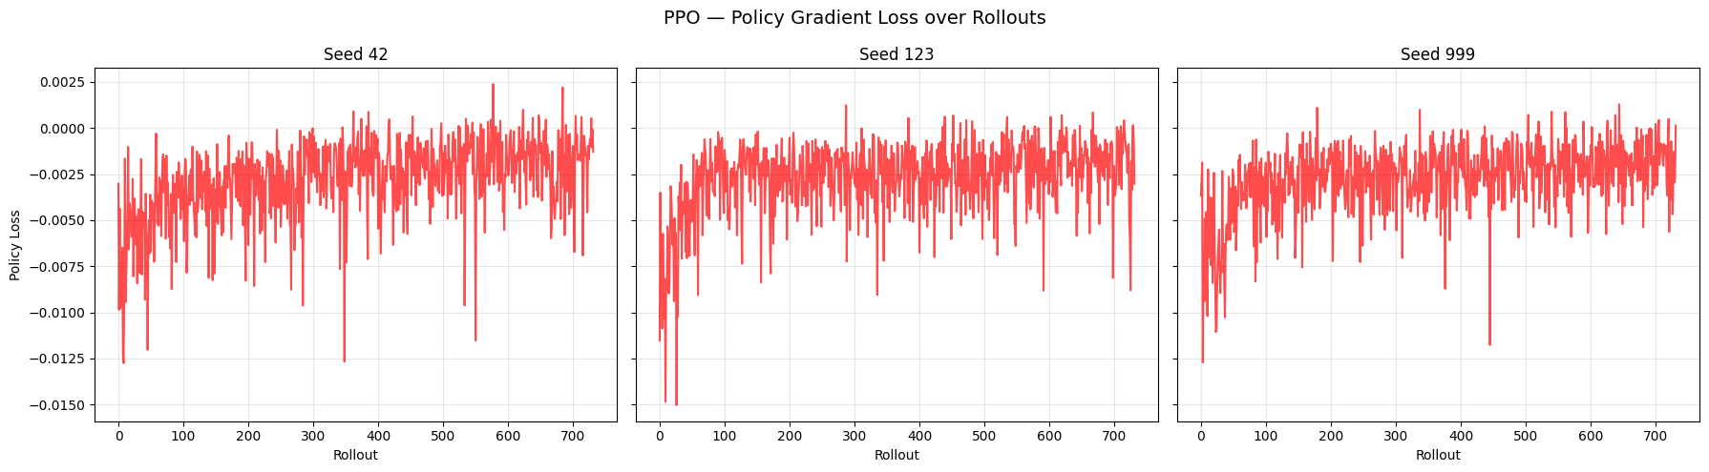

# DQN Overestimation: Mean Max Q-Value over Training  
  
fig, axes = plt.subplots(1, len(SEED_LIST), figsize=(6 * len(SEED_LIST), 5), sharey=True)  
if len(SEED_LIST) == 1:  
 axes = [axes]  
  
for ax, seed in zip(axes, SEED_LIST):  
 q_vals = training_results["dqn"][seed].mean_q_values  
 if q_vals:  
 ax.plot(q_vals, alpha=0.7, color="darkorange")  
 ax.set_title(f"Seed {seed}")  
 ax.set_xlabel("Rollout")  
 ax.grid(True, alpha=0.3)  
  
axes[0].set_ylabel("Mean Max Q-Value")  
fig.suptitle("DQN \u2014 Q-Value Overestimation Tracking", fontsize=14)  
plt.tight_layout()  
plt.show()  
  
print("Note: Steadily rising Q-values that diverge from actual returns indicate overestimation.")  
print("A stable or slowly growing curve suggests the target network is controlling overestimation.")

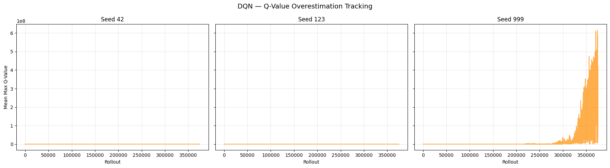

Note: Steadily rising Q-values that diverge from actual returns indicate overestimation.  
A stable or slowly growing curve suggests the target network is controlling overestimation.

# PPO Update Stability: Clip Fraction, Approx KL, Explained Variance  
  
fig, axes = plt.subplots(3, len(SEED_LIST), figsize=(6 * len(SEED_LIST), 12), sharex=True)  
if len(SEED_LIST) == 1:  
 axes = axes.reshape(3, 1)  
  
metrics = [  
 ("clip_fraction", "Clip Fraction", "tab:red",  
 "Fraction of policy updates clipped by PPO. High values suggest the policy is changing too fast."),  
 ("approx_kl", "Approx KL Divergence", "tab:purple",  
 "KL divergence between old and new policy. Spikes indicate large policy shifts."),  
 ("explained_variance", "Explained Variance", "tab:cyan",  
 "How well the value function predicts returns. 1.0 = perfect, 0 = no better than mean."),  
]  
  
for row, (attr, ylabel, color, _) in enumerate(metrics):  
 for col, seed in enumerate(SEED_LIST):  
 data = getattr(training_results["ppo"][seed], attr)  
 if data:  
 axes[row][col].plot(data, alpha=0.7, color=color)  
 if row == 0:  
 axes[row][col].set_title(f"Seed {seed}")  
 if row == 2:  
 axes[row][col].set_xlabel("Rollout")  
 axes[row][col].grid(True, alpha=0.3)  
 axes[row][0].set_ylabel(ylabel)  
  
fig.suptitle("PPO \u2014 Update Stability Metrics over Rollouts", fontsize=14)  
plt.tight_layout()  
plt.show()  
  
for _, ylabel, _, description in metrics:  
 print(f" {ylabel}: {description}")

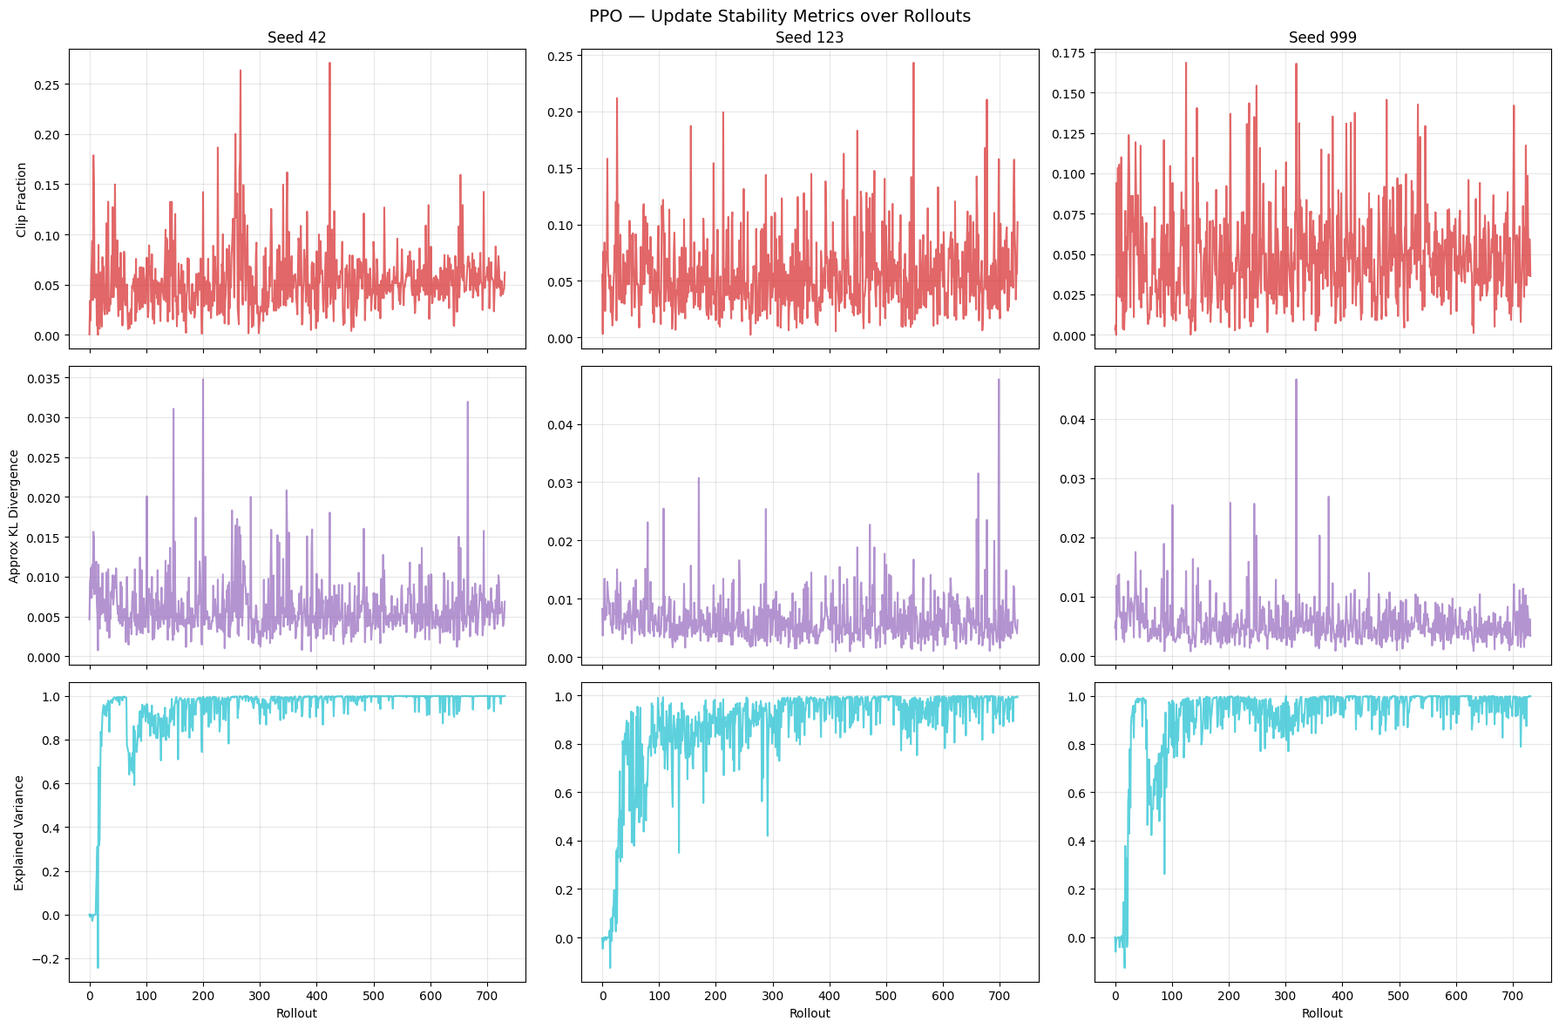

Clip Fraction: Fraction of policy updates clipped by PPO. High values suggest the policy is changing too fast.  
 Approx KL Divergence: KL divergence between old and new policy. Spikes indicate large policy shifts.  
 Explained Variance: How well the value function predicts returns. 1.0 = perfect, 0 = no better than mean.

# Aggregated: Rolling Reward Overlay — per algorithm (all seeds on one chart)  
  
seed_colors = list(plt.colormaps["tab10"](range(10))) # type: ignore[arg-type]  
  
for algo_name in ALGORITHM_MAP:  
 plt.figure(figsize=(14, 6))  
 for i, seed in enumerate(SEED_LIST):  
 rewards = training_results[algo_name][seed].episode_rewards  
 rolling = pd.Series(rewards).rolling(50).mean()  
 plt.plot(rolling, color=seed_colors[i], linewidth=2, label=f"Seed {seed}")  
  
 plt.axhline(y=200, color='red', linestyle='--', label='Solved Threshold (200)')  
 plt.title(f"{algo_name.upper()} Training: Rolling Mean Reward (window=50)", fontsize=14)  
 plt.xlabel("Episode")  
 plt.ylabel("Reward")  
 plt.legend()  
 plt.grid(True, alpha=0.3)  
 plt.show()

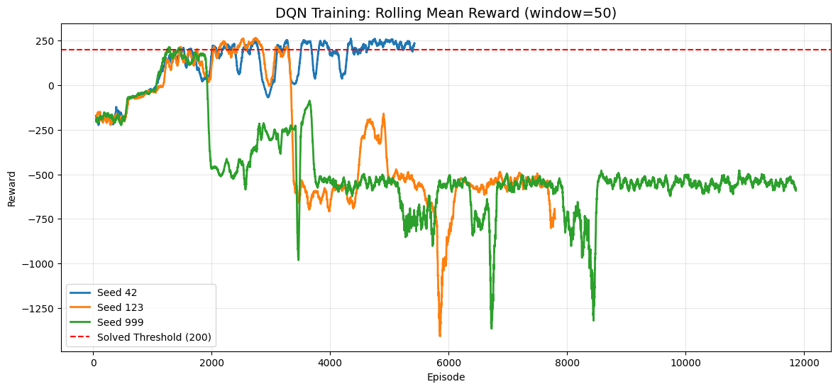

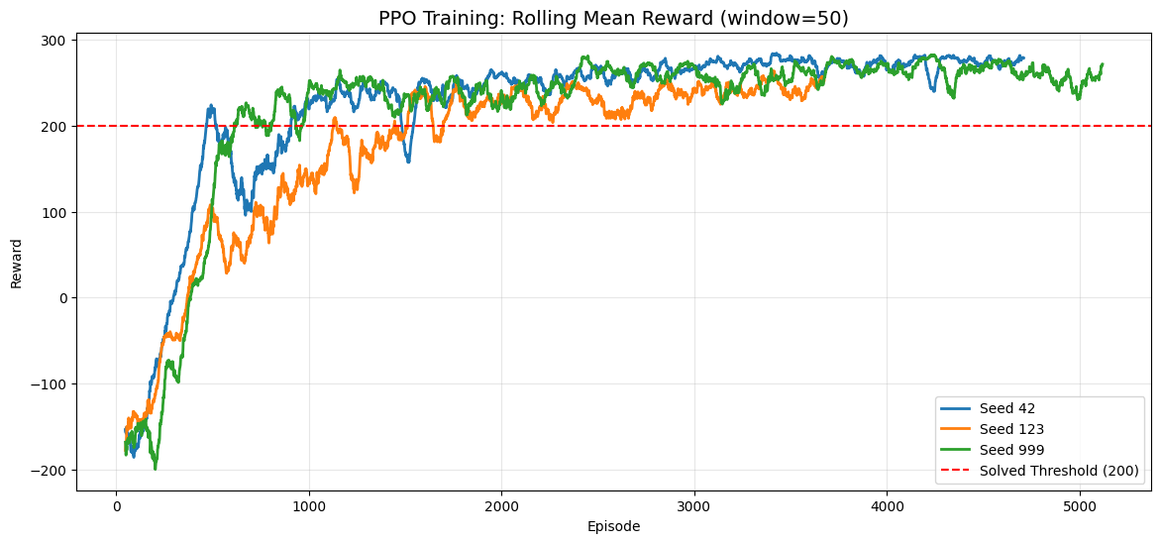

# Per-Algorithm: Rolling Success Rate over Training (window=50)  
  
for algo_name in ALGORITHM_MAP:  
 plt.figure(figsize=(14, 6))  
 for i, seed in enumerate(SEED_LIST):  
 rewards = np.array(training_results[algo_name][seed].episode_rewards)  
 success = (rewards >= 200).astype(float)  
 rolling_success = pd.Series(success).rolling(50).mean() * 100  
 plt.plot(rolling_success, color=seed_colors[i], linewidth=2, label=f"Seed {seed}")  
  
 plt.axhline(y=100, color='green', linestyle=':', alpha=0.4, label='100%')  
 plt.axhline(y=50, color='gray', linestyle=':', alpha=0.4, label='50%')  
 plt.title(f"{algo_name.upper()} Training: Rolling Success Rate (window=50)", fontsize=14)  
 plt.xlabel("Episode")  
 plt.ylabel("Success Rate (%)")  
 plt.ylim(-5, 105)  
 plt.legend()  
 plt.grid(True, alpha=0.3)  
 plt.show()

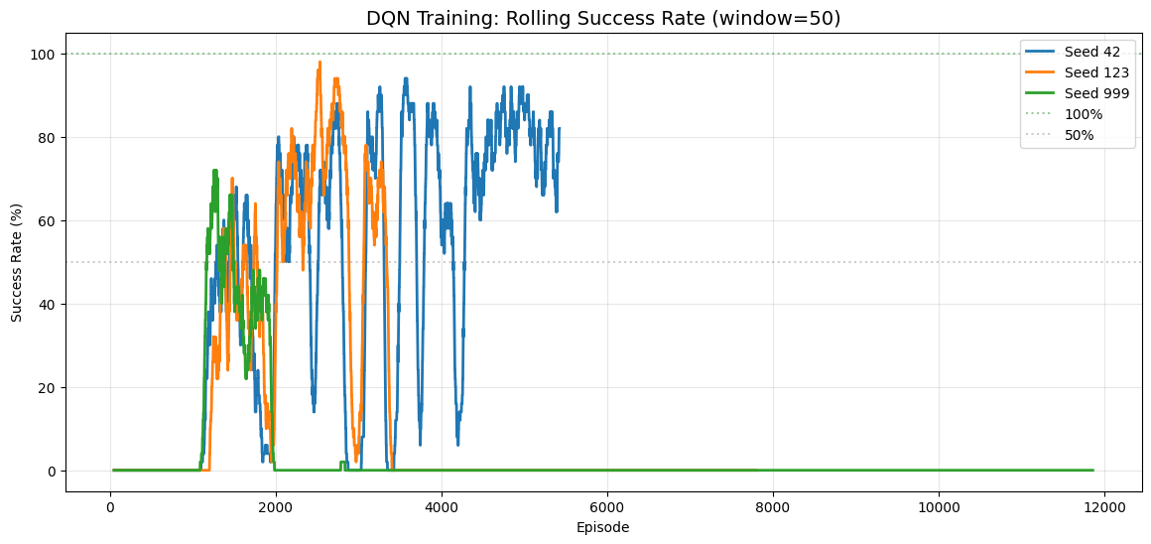

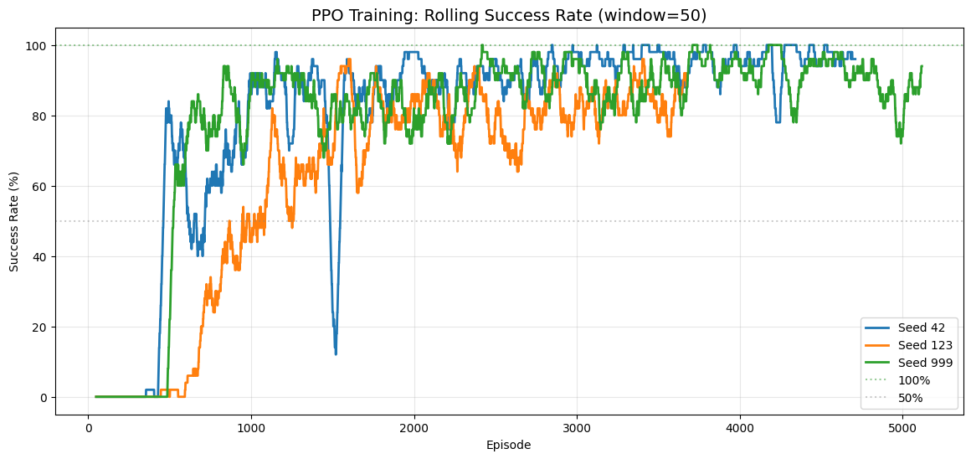

# Cross-Algorithm Comparison: Success Rate over Training (averaged across seeds)  
  
algo_colors = {"dqn": "tab:blue", "ppo": "tab:orange"}  
  
plt.figure(figsize=(14, 6))  
for algo_name in ALGORITHM_MAP:  
 min_len = min(len(training_results[algo_name][s].episode_rewards) for s in SEED_LIST)  
 all_rewards = np.array([training_results[algo_name][s].episode_rewards[:min_len] for s in SEED_LIST])  
 all_success = (all_rewards >= 200).astype(float)  
  
 mean_success = pd.Series(all_success.mean(axis=0)).rolling(50).mean() * 100  
 std_success = pd.Series(all_success.std(axis=0)).rolling(50).mean() * 100  
  
 episodes = np.arange(len(mean_success))  
 plt.plot(episodes, mean_success, color=algo_colors[algo_name], linewidth=2,  
 label=f"{algo_name.upper()} (mean)")  
 plt.fill_between(episodes, mean_success - std_success, mean_success + std_success,  
 color=algo_colors[algo_name], alpha=0.15)  
  
plt.axhline(y=100, color='green', linestyle=':', alpha=0.4, label='100%')  
plt.axhline(y=50, color='gray', linestyle=':', alpha=0.4, label='50%')  
plt.title("DQN vs PPO: Mean Success Rate across Seeds (window=50)", fontsize=14)  
plt.xlabel("Episode")  
plt.ylabel("Success Rate (%)")  
plt.ylim(-5, 105)  
plt.legend()  
plt.grid(True, alpha=0.3)  
plt.show()

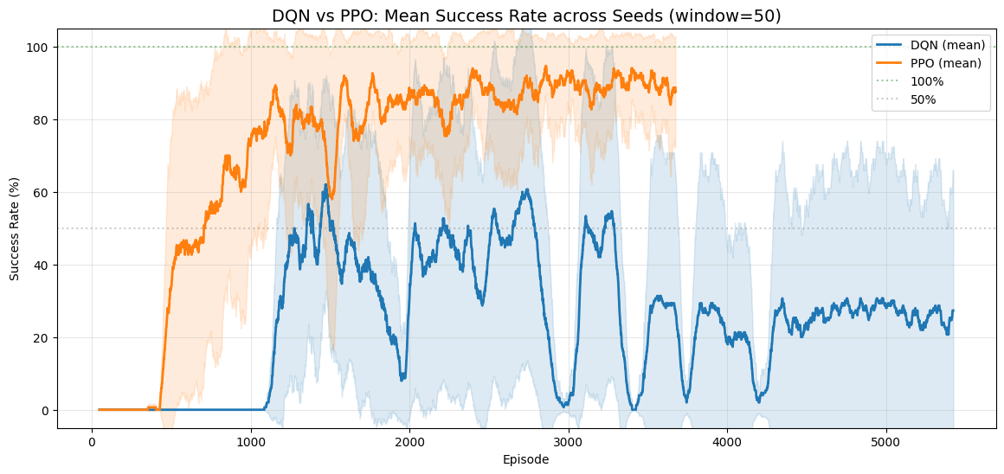

# Cross-Algorithm Comparison: Rolling Reward (averaged across seeds)  
  
algo_colors = {"dqn": "tab:blue", "ppo": "tab:orange"}  
  
plt.figure(figsize=(14, 6))  
for algo_name in ALGORITHM_MAP:  
 # Find the shortest episode count across seeds for alignment  
 min_len = min(len(training_results[algo_name][s].episode_rewards) for s in SEED_LIST)  
 all_rewards = np.array([training_results[algo_name][s].episode_rewards[:min_len] for s in SEED_LIST])  
 mean_rewards = pd.Series(all_rewards.mean(axis=0)).rolling(50).mean()  
 std_rewards = pd.Series(all_rewards.std(axis=0)).rolling(50).mean()  
  
 episodes = np.arange(len(mean_rewards))  
 plt.plot(episodes, mean_rewards, color=algo_colors[algo_name], linewidth=2, label=f"{algo_name.upper()} (mean)")  
 plt.fill_between(episodes, mean_rewards - std_rewards, mean_rewards + std_rewards,  
 color=algo_colors[algo_name], alpha=0.15)  
  
plt.axhline(y=200, color='red', linestyle='--', label='Solved Threshold (200)')  
plt.title("DQN vs PPO: Mean Rolling Reward across Seeds (window=50)", fontsize=14)  
plt.xlabel("Episode")  
plt.ylabel("Reward")  
plt.legend()  
plt.grid(True, alpha=0.3)  
plt.show()

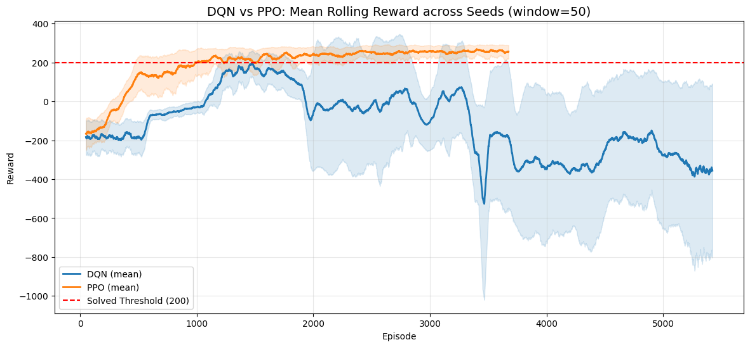

# Evaluation: deterministic episodes per algorithm per seed (best model)  
  
evaluation_results = {} # {algo: {seed: np.array}}  
  
for algo_name, algo_class in ALGORITHM_MAP.items():  
 evaluation_results[algo_name] = {}  
  
 for seed in SEED_LIST:  
 print(f"Evaluating {algo_name.upper()} seed {seed} (best model)...")  
  
 set_all_seeds(seed)  
  
 best_path = model_save_paths[algo_name][seed]["best"]  
  
 def make_eval_env(s=seed):  
 env = gym.make(GYMNASIUM_MODEL, render_mode="rgb_array", enable_wind=WIND_ENABLED)  
 env.reset(seed=s)  
 return env  
  
 eval_model = algo_class.load(best_path, env=DummyVecEnv([make_eval_env]), device=DEVICE)  
  
 eval_env = Monitor(gym.make(GYMNASIUM_MODEL, enable_wind=WIND_ENABLED))  
 eval_env.reset(seed=seed)  
  
 rewards, _ = evaluate_policy(  
 eval_model,  
 eval_env,  
 n_eval_episodes=EVALUATION_EPISODES,  
 deterministic=True,  
 return_episode_rewards=True  
 )  
  
 evaluation_results[algo_name][seed] = np.array(rewards)  
 eval_env.close()  
  
print(f"\nEvaluation complete for all algorithms and seeds.")

Evaluating DQN seed 42 (best model)...  
Evaluating DQN seed 123 (best model)...  
Evaluating DQN seed 999 (best model)...  
Evaluating PPO seed 42 (best model)...  
Evaluating PPO seed 123 (best model)...  
Evaluating PPO seed 999 (best model)...  
  
Evaluation complete for all algorithms and seeds.

# Evaluation Summary Tables (per algorithm + overall)  
  
for algo_name in ALGORITHM_MAP:  
 rows = []  
 for seed in SEED_LIST:  
 r = evaluation_results[algo_name][seed]  
 rows.append({  
 "Seed": seed,  
 "Mean Reward": f"{np.mean(r):.2f}",  
 "Std Dev": f"{np.std(r):.2f}",  
 "Min Reward": f"{np.min(r):.2f}",  
 "Max Reward": f"{np.max(r):.2f}",  
 "Success Rate": f"{(r >= 200).sum() / len(r) * 100:.1f}%"  
 })  
  
 all_r = np.concatenate([evaluation_results[algo_name][s] for s in SEED_LIST])  
 rows.append({  
 "Seed": "Overall",  
 "Mean Reward": f"{np.mean(all_r):.2f}",  
 "Std Dev": f"{np.std(all_r):.2f}",  
 "Min Reward": f"{np.min(all_r):.2f}",  
 "Max Reward": f"{np.max(all_r):.2f}",  
 "Success Rate": f"{(all_r >= 200).sum() / len(all_r) * 100:.1f}%"  
 })  
  
 print(f"*** {algo_name.upper()} MULTI-SEED EVALUATION SUMMARY ***")  
 print(f"Episodes per seed: {EVALUATION_EPISODES} | Total: {len(all_r)}")  
 print(pd.DataFrame(rows).to_string(index=False))  
 print()

*** DQN MULTI-SEED EVALUATION SUMMARY ***  
Episodes per seed: 20 | Total: 60  
 Seed Mean Reward Std Dev Min Reward Max Reward Success Rate  
 42 278.51 23.70 228.67 318.97 100.0%  
 123 283.34 18.19 250.33 319.93 100.0%  
 999 253.57 68.63 -28.26 305.91 95.0%  
Overall 271.80 45.14 -28.26 319.93 98.3%  
  
*** PPO MULTI-SEED EVALUATION SUMMARY ***  
Episodes per seed: 20 | Total: 60  
 Seed Mean Reward Std Dev Min Reward Max Reward Success Rate  
 42 278.43 14.56 251.45 311.70 100.0%  
 123 270.83 14.06 242.53 292.55 100.0%  
 999 284.32 18.77 252.25 317.36 100.0%  
Overall 277.86 16.87 242.53 317.36 100.0%

# Cross-Algorithm Comparison: Bar Chart  
  
algo_names = list(ALGORITHM_MAP.keys())  
n_algos = len(algo_names)  
n_seeds = len(SEED_LIST)  
bar_width = 0.8 / n_algos  
x = np.arange(n_seeds)  
  
plt.figure(figsize=(max(10, 3 * n_seeds), 6))  
for i, algo_name in enumerate(algo_names):  
 means = [np.mean(evaluation_results[algo_name][s]) for s in SEED_LIST]  
 stds = [np.std(evaluation_results[algo_name][s]) for s in SEED_LIST]  
 offset = (i - (n_algos - 1) / 2) * bar_width  
 plt.bar(x + offset, means, bar_width, yerr=stds, capsize=4,  
 label=algo_name.upper(), alpha=0.8)  
  
plt.axhline(y=200, color='red', linestyle='--', label='Solved Threshold (200)')  
plt.xticks(x, [str(s) for s in SEED_LIST])  
plt.title(f"DQN vs PPO: Mean Reward per Seed ({EVALUATION_EPISODES} episodes each)", fontsize=14)  
plt.xlabel("Seed")  
plt.ylabel("Mean Reward")  
plt.legend()  
plt.grid(True, alpha=0.3, axis='y')  
plt.show()

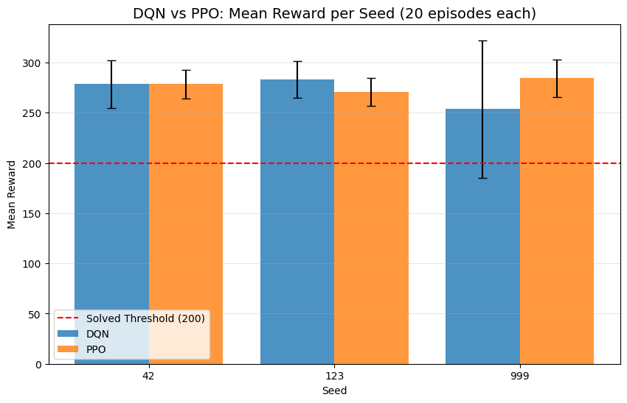

# Per-Algorithm: Evaluation Convergence Plots  
  
for algo_name in ALGORITHM_MAP:  
 fig, axes = plt.subplots(1, len(SEED_LIST), figsize=(6 * len(SEED_LIST), 5), sharey=True)  
 if len(SEED_LIST) == 1:  
 axes = [axes]  
  
 for ax, seed in zip(axes, SEED_LIST):  
 rewards = evaluation_results[algo_name][seed]  
 episodes = np.arange(1, len(rewards) + 1)  
 running_mean = np.cumsum(rewards) / episodes  
  
 ax.scatter(episodes, rewards, color='gray', alpha=0.4, s=20)  
 ax.plot(episodes, running_mean, color='blue', linewidth=2)  
 ax.axhline(y=200, color='red', linestyle='--')  
 ax.set_title(f"Seed {seed}")  
 ax.set_xlabel("Episode")  
 ax.grid(True, alpha=0.3)  
  
 axes[0].set_ylabel("Reward")  
 fig.suptitle(f"{algo_name.upper()} Evaluation: {EVALUATION_EPISODES} Episodes per Seed", fontsize=14)  
 plt.tight_layout()  
 plt.show()

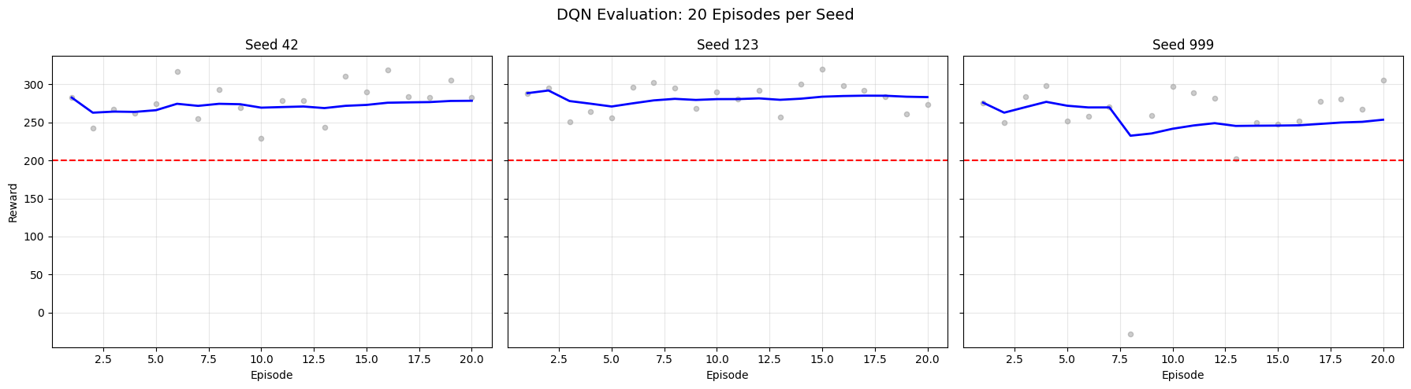

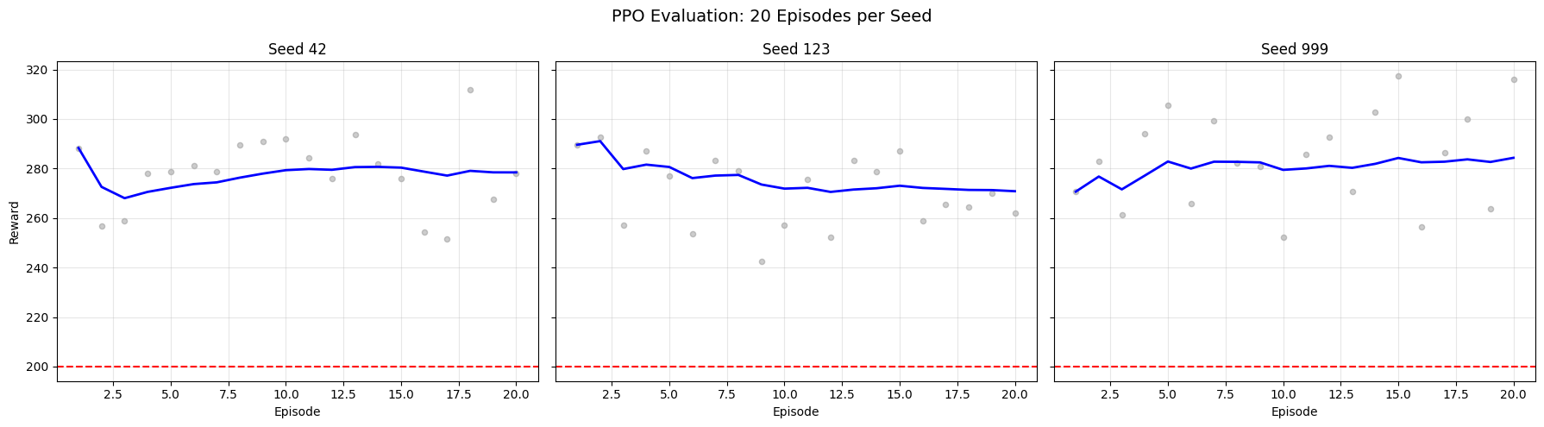

# GIF Visualization (one per algorithm per seed, best model)  
  
for algo_name, algo_class in ALGORITHM_MAP.items():  
 output_dir = os.path.join(NOTEBOOK_DIR, "outputs_" + algo_name)  
 os.makedirs(output_dir, exist_ok=True)  
  
 for seed in SEED_LIST:  
 print(f"Generating GIF for {algo_name.upper()} seed {seed} (best model)...")  
  
 best_path = model_save_paths[algo_name][seed]["best"]  
  
 def make_vis_env(s=seed):  
 env = gym.make(GYMNASIUM_MODEL, render_mode="rgb_array", enable_wind=WIND_ENABLED)  
 env.reset(seed=s)  
 return env  
  
 vis_model = algo_class.load(best_path, env=DummyVecEnv([make_vis_env]), device=DEVICE)  
  
 vis_env = gym.make(GYMNASIUM_MODEL, render_mode="rgb_array", enable_wind=WIND_ENABLED)  
 frames = []  
 obs, info = vis_env.reset(seed=seed)  
 done = False  
  
 while not done:  
 action, _ = vis_model.predict(obs, deterministic=True)  
 obs, reward, terminated, truncated, info = vis_env.step(action)  
 done = terminated or truncated  
 frames.append(vis_env.render())  
  
 vis_env.close()  
  
 gif_path = os.path.join(output_dir, f"{algo_name}_seed{seed}.gif")  
 imageio.mimsave(gif_path, frames, fps=30)  
 print(f" Saved: {gif_path}")  
 display(Image(filename=gif_path))

Generating GIF for DQN seed 42 (best model)...  
 Saved: /home/logus/env/iscte/taap_p2/drafts/draft_01/gymnasium/outputs_dqn/dqn_seed42.gif  
  
  
  
<IPython.core.display.Image object>  
  
  
Generating GIF for DQN seed 123 (best model)...  
 Saved: /home/logus/env/iscte/taap_p2/drafts/draft_01/gymnasium/outputs_dqn/dqn_seed123.gif  
  
  
  
<IPython.core.display.Image object>  
  
  
Generating GIF for DQN seed 999 (best model)...  
 Saved: /home/logus/env/iscte/taap_p2/drafts/draft_01/gymnasium/outputs_dqn/dqn_seed999.gif  
  
  
  
<IPython.core.display.Image object>  
  
  
Generating GIF for PPO seed 42 (best model)...  
 Saved: /home/logus/env/iscte/taap_p2/drafts/draft_01/gymnasium/outputs_ppo/ppo_seed42.gif  
  
  
  
<IPython.core.display.Image object>  
  
  
Generating GIF for PPO seed 123 (best model)...  
 Saved: /home/logus/env/iscte/taap_p2/drafts/draft_01/gymnasium/outputs_ppo/ppo_seed123.gif  
  
  
  
<IPython.core.display.Image object>  
  
  
Generating GIF for PPO seed 999 (best model)...  
 Saved: /home/logus/env/iscte/taap_p2/drafts/draft_01/gymnasium/outputs_ppo/ppo_seed999.gif  
  
  
  
<IPython.core.display.Image object>

# Hyperparameter Tables  
  
for algo_name in ALGORITHM_MAP:  
 params = ALGO_PARAMS[algo_name]  
 rows = [{"Parameter": k, "Value": str(v)} for k, v in params.items()]  
 rows.append({"Parameter": "total_timesteps", "Value": str(TOTAL_TIMESTEPS)})  
 rows.append({"Parameter": "device", "Value": DEVICE})  
 rows.append({"Parameter": "policy", "Value": MLP_POLICY})  
 rows.append({"Parameter": "checkpoint_freq_episodes", "Value": str(CHECKPOINT_FREQ_EPISODES)})  
 rows.append({"Parameter": "eval_freq_timesteps", "Value": str(EVAL_FREQ_TIMESTEPS)})  
 rows.append({"Parameter": "eval_n_episodes", "Value": str(EVAL_N_EPISODES)})  
  
 print(f"*** {algo_name.upper()} Hyperparameters ***")  
 print(pd.DataFrame(rows).to_string(index=False))  
 print()

*** DQN Hyperparameters ***  
 Parameter Value  
 policy MlpPolicy  
 learning_rate <function linear_schedule.<locals>.func at 0x7058383c3560>  
 learning_starts 50000  
 buffer_size 750000  
 batch_size 128  
 gamma 0.99  
 exploration_fraction 0.12  
 exploration_final_eps 0.1  
 target_update_interval 250  
 train_freq 4  
 gradient_steps 4  
 policy_kwargs {'net_arch': [256, 256]}  
 device cpu  
 total_timesteps 1500000  
 device cpu  
 policy MlpPolicy  
checkpoint_freq_episodes 100  
 eval_freq_timesteps 25000  
 eval_n_episodes 20  
  
*** PPO Hyperparameters ***  
 Parameter Value  
 learning_rate 0.00025  
 n_steps 2048  
 batch_size 64  
 n_epochs 10  
 gamma 0.999  
 gae_lambda 0.95  
 ent_coef 0.01  
 clip_range 0.2  
 total_timesteps 1500000  
 device cpu  
 policy MlpPolicy  
checkpoint_freq_episodes 100  
 eval_freq_timesteps 25000  
 eval_n_episodes 20

# Recovery: Reconstruct Best-Model Summary from saved eval logs  
# This cell is standalone — it scans models/ folders and rebuilds the table  
# from evaluations.npz files, without needing a prior training run in memory.  
#  
# Results are GROUPED BY SESSION (lab prefix), so seeds trained together  
# in the same notebook run are shown together.  
  
import glob  
  
models_root = os.path.join(NOTEBOOK_DIR, "../../../models")  
  
# Collect all completed run data  
all_runs = [] # list of dicts with session, algo, seed, scores, folder  
  
for algo_name in ["dqn", "ppo"]:  
 algo_dir = os.path.join(models_root, algo_name)  
 if not os.path.isdir(algo_dir):  
 continue  
  
 for run_folder in sorted(glob.glob(os.path.join(algo_dir, "????-??-??_??_??_??"))):  
 best_model_path = os.path.join(run_folder, "best_model.zip")  
 eval_log_path = os.path.join(run_folder, "eval_log", "evaluations.npz")  
  
 if not os.path.isfile(best_model_path):  
 continue # incomplete run, skip  
  
 # Extract session (lab prefix) and seed from the final model filename  
 # e.g. lab009_dqn_42.zip -> session="lab009", seed="42"  
 session = "unknown"  
 seed_str = "?"  
 for f in os.listdir(run_folder):  
 if f.startswith("lab") and f.endswith(".zip") and f != "best_model.zip":  
 parts = f.replace(".zip", "").split("_")  
 # parts = ["lab009", "dqn", "42"]  
 session = parts[0] if len(parts) >= 1 else "unknown"  
 seed_str = parts[-1] if len(parts) >= 3 else "?"  
 break  
  
 timestamp = os.path.basename(run_folder)  
  
 run_entry = {  
 "session": session,  
 "algo": algo_name.upper(),  
 "seed": seed_str,  
 "timestamp": timestamp,  
 "folder": f"models/{algo_name}/{timestamp}/",  
 }  
  
 if os.path.isfile(eval_log_path):  
 data = np.load(eval_log_path, allow_pickle=True)  
 timesteps = data["timesteps"]  
 results = data["results"]  
  
 best_score = -np.inf  
 best_idx = 0  
 for i in range(len(timesteps)):  
 ep_rewards = results[i]  
 score = np.mean(ep_rewards) - np.std(ep_rewards)  
 if score > best_score:  
 best_score = score  
 best_idx = i  
  
 ep = results[best_idx]  
 run_entry.update({ # type: ignore  
 "mean_reward": np.mean(ep),  
 "std_reward": np.std(ep),  
 "success": np.sum(ep >= 200) / len(ep) * 100,  
 "score": best_score,  
 "timestep": int(timesteps[best_idx]),  
 "has_eval": True,  
 })  
 else:  
 run_entry["has_eval"] = False # type: ignore  
  
 all_runs.append(run_entry)  
  
# Group by session  
sessions = sorted(set(r["session"] for r in all_runs))  
  
if not all_runs:  
 print("No completed training runs found in models/.")  
else:  
 for session in sessions:  
 session_runs = [r for r in all_runs if r["session"] == session]  
  
 print(f"{'='*70}")  
 print(f"SESSION: {session}")  
 print(f"{'='*70}")  
  
 rows = []  
 for r in sorted(session_runs, key=lambda x: (x["algo"], x["seed"])):  
 if r["has_eval"]:  
 rows.append({  
 "Algorithm": r["algo"],  
 "Seed": r["seed"],  
 "Mean Reward": f"{r['mean_reward']:.2f}",  
 "Std Reward": f"{r['std_reward']:.2f}",  
 "Success": f"{r['success']:.0f}%",  
 "Score (mean-std)": f"{r['score']:.2f}",  
 "@ Timestep": f"{r['timestep']:,}",  
 "Run Folder": r["folder"],  
 })  
 else:  
 rows.append({  
 "Algorithm": r["algo"],  
 "Seed": r["seed"],  
 "Mean Reward": "N/A",  
 "Std Reward": "N/A",  
 "Success": "N/A",  
 "Score (mean-std)": "N/A",  
 "@ Timestep": "N/A",  
 "Run Folder": r["folder"] + " (no eval log)",  
 })  
  
 print(pd.DataFrame(rows).to_string(index=False))  
 print(f"\nRuns in this session: {len(session_runs)}")  
 print(f"Each 'Run Folder' contains: best_model.zip, checkpoints/, eval_log/")  
 print()

======================================================================  
SESSION: lab008  
======================================================================  
Algorithm Seed Mean Reward Std Reward Success Score (mean-std) @ Timestep Run Folder  
 DQN 123 281.04 15.87 100% 265.17 1,225,000 models/dqn/2026-02-20_19_35_00/  
 DQN 42 288.80 12.56 100% 276.24 1,425,000 models/dqn/2026-02-20_18_14_51/  
 DQN 999 288.09 15.54 100% 272.54 1,000,000 models/dqn/2026-02-20_20_44_57/  
 PPO 123 279.66 8.66 100% 271.00 1,375,000 models/ppo/2026-02-20_22_53_14/  
 PPO 42 277.43 12.87 100% 264.56 1,150,000 models/ppo/2026-02-20_21_57_35/  
 PPO 999 289.56 17.39 100% 272.17 1,350,000 models/ppo/2026-02-20_23_52_44/  
  
Runs in this session: 6  
Each 'Run Folder' contains: best_model.zip, checkpoints/, eval_log/  
  
======================================================================  
SESSION: lab009  
======================================================================  
Algorithm Seed Mean Reward Std Reward Success Score (mean-std) @ Timestep Run Folder  
 DQN 123 275.61 15.80 100% 259.82 875,000 models/dqn/2026-02-21_12_32_15/  
 DQN 123 275.61 15.80 100% 259.82 875,000 models/dqn/2026-02-21_15_59_14/  
 DQN 123 275.61 15.80 100% 259.82 875,000 models/dqn/2026-02-21_21_35_46/  
 DQN 42 283.33 16.29 100% 267.04 1,450,000 models/dqn/2026-02-21_05_29_23/  
 DQN 42 283.74 17.39 100% 266.35 1,425,000 models/dqn/2026-02-21_11_41_19/  
 DQN 42 283.74 17.39 100% 266.35 1,425,000 models/dqn/2026-02-21_15_08_14/  
 DQN 42 283.74 17.39 100% 266.35 1,425,000 models/dqn/2026-02-21_20_43_20/  
 DQN 999 266.25 22.38 100% 243.87 550,000 models/dqn/2026-02-21_13_20_30/  
 DQN 999 266.25 22.38 100% 243.87 550,000 models/dqn/2026-02-21_16_50_05/  
 DQN 999 266.25 22.38 100% 243.87 550,000 models/dqn/2026-02-21_22_27_19/  
 PPO 123 -968.15 319.34 0% -1287.49 150,000 models/ppo/2026-02-21_14_33_00/  
 PPO 123 -968.15 319.34 0% -1287.49 150,000 models/ppo/2026-02-21_18_03_12/  
 PPO 123 267.61 18.14 100% 249.47 1,300,000 models/ppo/2026-02-21_23_39_19/  
 PPO 42 -868.29 300.16 0% -1168.45 100,000 models/ppo/2026-02-21_14_09_36/  
 PPO 42 -868.29 300.16 0% -1168.45 100,000 models/ppo/2026-02-21_17_40_16/  
 PPO 42 289.50 21.48 100% 268.02 1,500,000 models/ppo/2026-02-21_23_17_45/  
 PPO 999 -794.03 451.90 0% -1245.93 250,000 models/ppo/2026-02-21_18_25_37/  
 PPO 999 285.68 19.69 100% 266.00 1,175,000 models/ppo/2026-02-22_00_03_53/  
  
Runs in this session: 18  
Each 'Run Folder' contains: best_model.zip, checkpoints/, eval_log/  
  
======================================================================  
SESSION: unknown  
======================================================================  
Algorithm Seed Mean Reward Std Reward Success Score (mean-std) @ Timestep Run Folder  
 DQN ? 256.82 20.28 100% 236.55 125,000 models/dqn/2026-02-21_07_02_05/  
 PPO ? -794.03 451.90 0% -1245.93 250,000 models/ppo/2026-02-21_14_55_39/  
  
Runs in this session: 2  
Each 'Run Folder' contains: best_model.zip, checkpoints/, eval_log/

# DQN & PPO Multi-Seed Report (Best Model Selection)

This notebook loads the **best model** from each training run (selected by the combined metric mean_reward - std_reward during training) and runs evaluation and visualization.

No training is required — run lab009_v1.ipynb first to generate the model files.

Models are loaded from timestamped run folders: models/{algo}/{timestamp}/best_model.zip

import os, sys  
  
import numpy as np  
import pandas as pd  
import torch  
import matplotlib.pyplot as plt  
from scipy import stats  
  
import gymnasium as gym  
from stable_baselines3 import DQN, PPO  
from stable_baselines3.common.evaluation import evaluate_policy  
from stable_baselines3.common.vec_env import DummyVecEnv  
from stable_baselines3.common.monitor import Monitor  
  
import imageio  
from IPython.display import Image, display

# Configuration  
  
import glob  
  
SEED_LIST = [42, 123, 999]  
  
ALGORITHM_MAP = {  
 "dqn": DQN,  
 "ppo": PPO,  
}  
  
NOTEBOOK_DIR = os.path.dirname(os.path.abspath("__file__"))  
GYMNASIUM_MODEL = "LunarLander-v3"  
  
WIND_ENABLED = False  
  
EVALUATION_EPISODES = 20  
  
TRAJECTORY_EPISODES = 3 # Episodes to visualize per algorithm for trajectory plots  
  
DEVICE = "cpu"  
  
# Session prefix — must match the final model filenames from training  
# (e.g. lab009_dqn_42.zip -> SESSION_PREFIX = "lab009")  
SESSION_PREFIX = "lab009"  
  
# LunarLander-v3 action labels  
ACTION_LABELS = ["Do Nothing", "Fire Left", "Fire Main", "Fire Right"]  
  
  
def discover_best_models(session_prefix):  
 """  
 Scan models/{algo}/{timestamp}/ folders and return a dict:  
 {algo: {seed: path_to_best_model}}  
 Only considers runs whose final model filename starts with session_prefix.  
 """  
 models_root = os.path.join(NOTEBOOK_DIR, "../../../models")  
 best_models = {}  
  
 for algo_name in ALGORITHM_MAP:  
 best_models[algo_name] = {}  
 algo_dir = os.path.join(models_root, algo_name)  
 if not os.path.isdir(algo_dir):  
 continue  
  
 for run_folder in sorted(glob.glob(os.path.join(algo_dir, "????-??-??_??_??_??"))):  
 best_model_path = os.path.join(run_folder, "best_model.zip")  
 if not os.path.isfile(best_model_path):  
 continue  
  
 # Find the final model file to extract session and seed  
 for f in os.listdir(run_folder):  
 if f.startswith(session_prefix) and f.endswith(".zip") and f != "best_model.zip":  
 seed_str = f.replace(".zip", "").split("_")[-1]  
 if seed_str.isdigit():  
 seed_int = int(seed_str)  
 if seed_int in SEED_LIST:  
 best_models[algo_name][seed_int] = best_model_path  
 break  
  
 return best_models  
  
  
# Discover best models for this session  
best_model_paths = discover_best_models(SESSION_PREFIX)  
  
print(f"Session: {SESSION_PREFIX}")  
print(f"Algorithms: {list(ALGORITHM_MAP.keys())}")  
print(f"Seeds: {SEED_LIST}")  
print(f"Wind enabled: {WIND_ENABLED}")  
print(f"Evaluation episodes per seed: {EVALUATION_EPISODES}")  
print(f"Device: {DEVICE}")  
print()  
print("Discovered best models:")  
for algo_name in ALGORITHM_MAP:  
 for seed in SEED_LIST:  
 path = best_model_paths.get(algo_name, {}).get(seed)  
 status = path if path else "NOT FOUND"  
 print(f" {algo_name.upper()} seed {seed}: {status}")

Session: lab009  
Algorithms: ['dqn', 'ppo']  
Seeds: [42, 123, 999]  
Wind enabled: False  
Evaluation episodes per seed: 20  
Device: cpu  
  
Discovered best models:  
 DQN seed 42: /home/logus/env/iscte/taap_p2/drafts/draft_01/gymnasium/../../../models/dqn/2026-02-21_20_43_20/best_model.zip  
 DQN seed 123: /home/logus/env/iscte/taap_p2/drafts/draft_01/gymnasium/../../../models/dqn/2026-02-21_21_35_46/best_model.zip  
 DQN seed 999: /home/logus/env/iscte/taap_p2/drafts/draft_01/gymnasium/../../../models/dqn/2026-02-21_22_27_19/best_model.zip  
 PPO seed 42: /home/logus/env/iscte/taap_p2/drafts/draft_01/gymnasium/../../../models/ppo/2026-02-21_23_17_45/best_model.zip  
 PPO seed 123: /home/logus/env/iscte/taap_p2/drafts/draft_01/gymnasium/../../../models/ppo/2026-02-21_23_39_19/best_model.zip  
 PPO seed 999: /home/logus/env/iscte/taap_p2/drafts/draft_01/gymnasium/../../../models/ppo/2026-02-22_00_03_53/best_model.zip

# Load all best models and evaluate  
  
evaluation_results = {} # {algo: {seed: np.array}}  
  
for algo_name, algo_class in ALGORITHM_MAP.items():  
 evaluation_results[algo_name] = {}  
  
 for seed in SEED_LIST:  
 load_path = best_model_paths.get(algo_name, {}).get(seed)  
 if load_path is None:  
 print(f"SKIPPING {algo_name.upper()} seed {seed} — best model not found")  
 continue  
  
 print(f"Loading and evaluating {algo_name.upper()} seed {seed} (best model)...")  
  
 def make_env(s=seed):  
 env = gym.make(GYMNASIUM_MODEL, render_mode="rgb_array", enable_wind=WIND_ENABLED)  
 env.reset(seed=s)  
 return env  
  
 model = algo_class.load(load_path, env=DummyVecEnv([make_env]), device=DEVICE)  
  
 eval_env = Monitor(gym.make(GYMNASIUM_MODEL, enable_wind=WIND_ENABLED))  
 eval_env.reset(seed=seed)  
  
 rewards, _ = evaluate_policy(  
 model,  
 eval_env,  
 n_eval_episodes=EVALUATION_EPISODES,  
 deterministic=True,  
 return_episode_rewards=True  
 )  
  
 evaluation_results[algo_name][seed] = np.array(rewards)  
 eval_env.close()  
  
 print(f"{algo_name.upper()}: evaluation complete.\n")  
  
print(f"All evaluations complete.")

Loading and evaluating DQN seed 42 (best model)...  
Loading and evaluating DQN seed 123 (best model)...  
Loading and evaluating DQN seed 999 (best model)...  
DQN: evaluation complete.  
  
Loading and evaluating PPO seed 42 (best model)...  
Loading and evaluating PPO seed 123 (best model)...  
Loading and evaluating PPO seed 999 (best model)...  
PPO: evaluation complete.  
  
All evaluations complete.

## Per-Algorithm Results

# Per-Algorithm: Evaluation Summary Tables  
  
for algo_name in ALGORITHM_MAP:  
 rows = []  
 for seed in SEED_LIST:  
 r = evaluation_results[algo_name][seed]  
 rows.append({  
 "Seed": seed,  
 "Mean Reward": f"{np.mean(r):.2f}",  
 "Std Dev": f"{np.std(r):.2f}",  
 "Min Reward": f"{np.min(r):.2f}",  
 "Max Reward": f"{np.max(r):.2f}",  
 "Success Rate": f"{(r >= 200).sum() / len(r) * 100:.1f}%"  
 })  
  
 all_r = np.concatenate([evaluation_results[algo_name][s] for s in SEED_LIST])  
 rows.append({  
 "Seed": "Overall",  
 "Mean Reward": f"{np.mean(all_r):.2f}",  
 "Std Dev": f"{np.std(all_r):.2f}",  
 "Min Reward": f"{np.min(all_r):.2f}",  
 "Max Reward": f"{np.max(all_r):.2f}",  
 "Success Rate": f"{(all_r >= 200).sum() / len(all_r) * 100:.1f}%"  
 })  
  
 print(f"*** {algo_name.upper()} MULTI-SEED EVALUATION SUMMARY ***")  
 print(f"Episodes per seed: {EVALUATION_EPISODES} | Total: {len(all_r)}")  
 print(pd.DataFrame(rows).to_string(index=False))  
 print()

*** DQN MULTI-SEED EVALUATION SUMMARY ***  
Episodes per seed: 20 | Total: 60  
 Seed Mean Reward Std Dev Min Reward Max Reward Success Rate  
 42 278.51 23.70 228.67 318.97 100.0%  
 123 283.34 18.19 250.33 319.93 100.0%  
 999 253.57 68.63 -28.26 305.91 95.0%  
Overall 271.80 45.14 -28.26 319.93 98.3%  
  
*** PPO MULTI-SEED EVALUATION SUMMARY ***  
Episodes per seed: 20 | Total: 60  
 Seed Mean Reward Std Dev Min Reward Max Reward Success Rate  
 42 278.43 14.56 251.45 311.70 100.0%  
 123 270.83 14.06 242.53 292.55 100.0%  
 999 284.32 18.77 252.25 317.36 100.0%  
Overall 277.86 16.87 242.53 317.36 100.0%

# Per-Algorithm, Per-Seed: Evaluation Convergence Plots  
  
for algo_name in ALGORITHM_MAP:  
 fig, axes = plt.subplots(1, len(SEED_LIST), figsize=(6 * len(SEED_LIST), 5), sharey=True)  
 if len(SEED_LIST) == 1:  
 axes = [axes]  
  
 for ax, seed in zip(axes, SEED_LIST):  
 rewards = evaluation_results[algo_name][seed]  
 episodes = np.arange(1, len(rewards) + 1)  
 running_mean = np.cumsum(rewards) / episodes  
 running_std = np.array([np.std(rewards[:i]) for i in episodes])  
  
 ax.scatter(episodes, rewards, color='gray', alpha=0.4, s=20, label='Episode Reward')  
 ax.plot(episodes, running_mean, color='blue', linewidth=2, label='Running Mean')  
 ax.fill_between(episodes, running_mean - running_std, running_mean + running_std,  
 color='blue', alpha=0.15)  
 ax.axhline(y=200, color='red', linestyle='--')  
 ax.set_title(f"Seed {seed}")  
 ax.set_xlabel("Episode")  
 ax.grid(True, alpha=0.3)  
  
 axes[0].set_ylabel("Reward")  
 fig.suptitle(f"{algo_name.upper()} Evaluation: {EVALUATION_EPISODES} Episodes per Seed", fontsize=14)  
 plt.tight_layout()  
 plt.show()

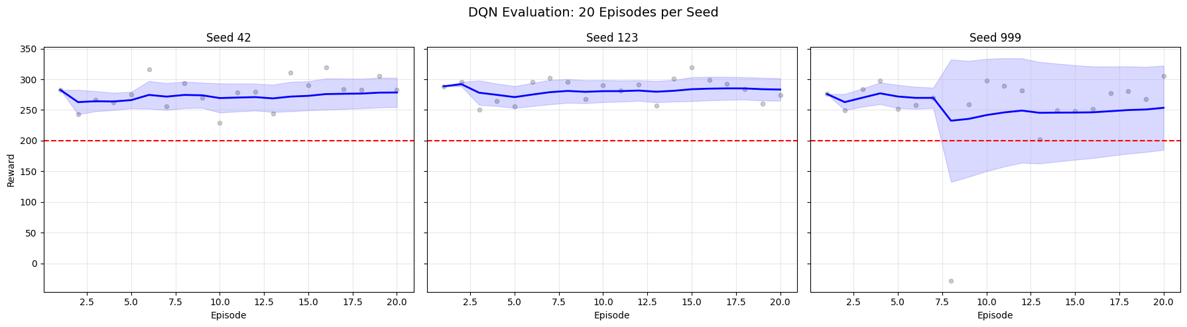

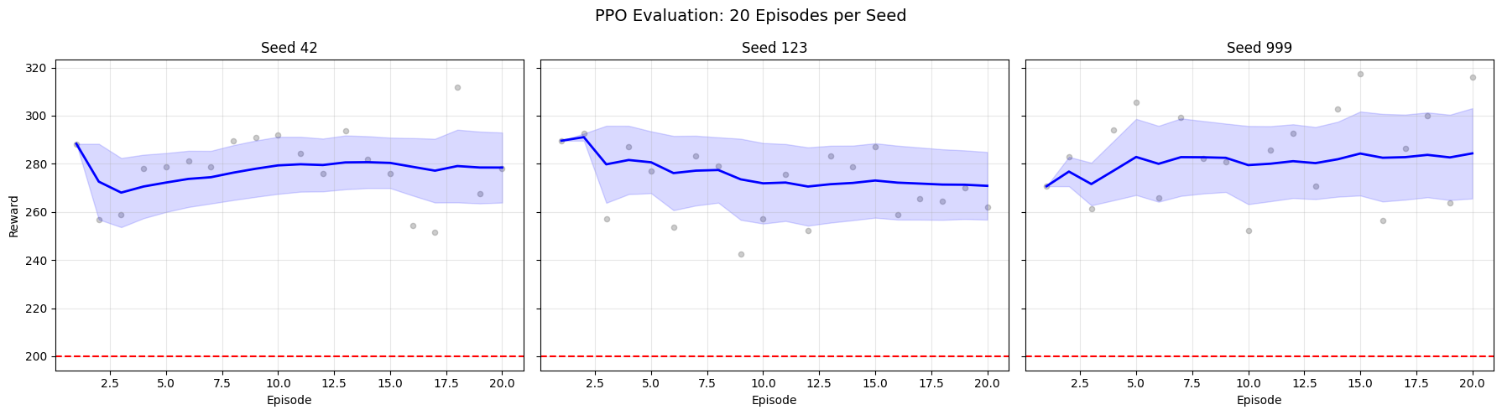

# Per-Algorithm: Evaluation Bar Chart (mean reward per seed with error bars)  
  
seed_colors = list(plt.colormaps["tab10"](range(10))) # type: ignore[arg-type]  
  
for algo_name in ALGORITHM_MAP:  
 all_r = np.concatenate([evaluation_results[algo_name][s] for s in SEED_LIST])  
 means = [np.mean(evaluation_results[algo_name][s]) for s in SEED_LIST]  
 stds = [np.std(evaluation_results[algo_name][s]) for s in SEED_LIST]  
 labels = [str(s) for s in SEED_LIST]  
  
 plt.figure(figsize=(max(8, 3 * len(SEED_LIST)), 6))  
 plt.bar(labels, means, yerr=stds, capsize=5, color=seed_colors[:len(SEED_LIST)], alpha=0.8)  
 plt.axhline(y=200, color='red', linestyle='--', label='Solved Threshold (200)')  
 plt.axhline(y=float(np.mean(all_r)), color='blue', linestyle='-', linewidth=2,  
 label=f'Overall Mean ({np.mean(all_r):.1f})')  
  
 plt.title(f"{algo_name.upper()} Mean Reward per Seed ({EVALUATION_EPISODES} episodes each)", fontsize=14)  
 plt.xlabel("Seed")  
 plt.ylabel("Mean Reward")  
 plt.legend()  
 plt.grid(True, alpha=0.3, axis='y')  
 plt.show()

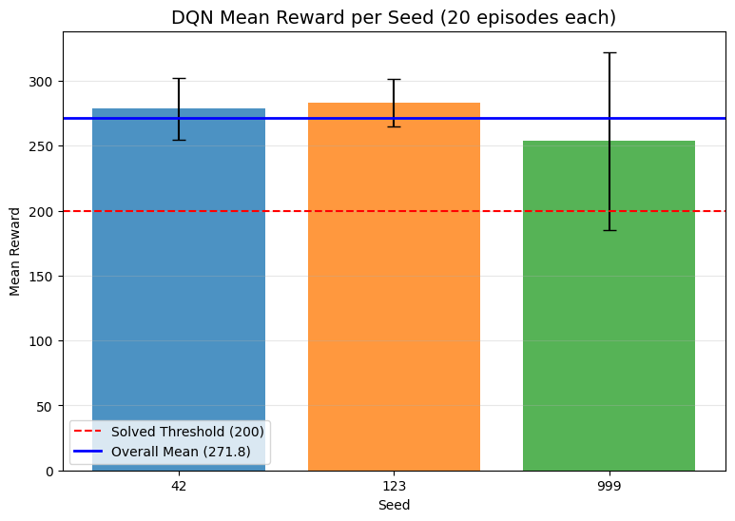

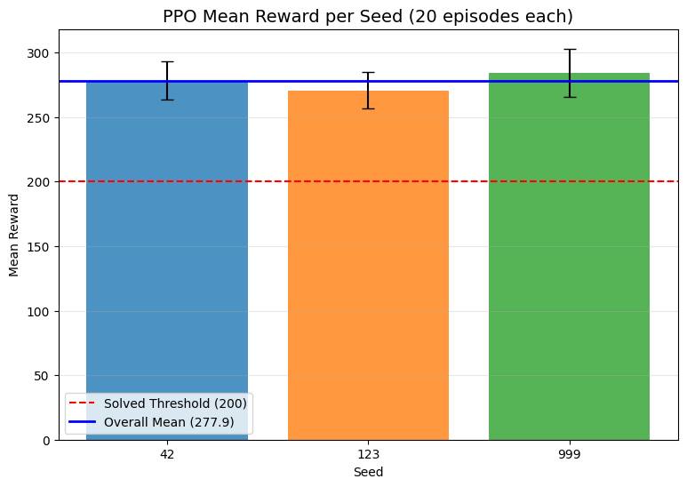

# Per-Algorithm: Reward Distribution Histograms (overlaid per seed)  
  
for algo_name in ALGORITHM_MAP:  
 all_r = np.concatenate([evaluation_results[algo_name][s] for s in SEED_LIST])  
  
 plt.figure(figsize=(12, 5))  
 for i, seed in enumerate(SEED_LIST):  
 plt.hist(evaluation_results[algo_name][seed], bins=10, alpha=0.5,  
 color=seed_colors[i], edgecolor='black', label=f"Seed {seed}")  
  
 plt.axvline(x=float(np.mean(all_r)), color='blue', linestyle='-', linewidth=2,  
 label=f'Overall Mean ({np.mean(all_r):.1f})')  
 plt.axvline(x=200, color='red', linestyle='--', label='Solved Threshold (200)')  
 plt.title(f'{algo_name.upper()} Reward Distribution across Seeds')  
 plt.xlabel('Reward')  
 plt.ylabel('Frequency')  
 plt.legend()  
 plt.grid(True, alpha=0.3)  
 plt.show()

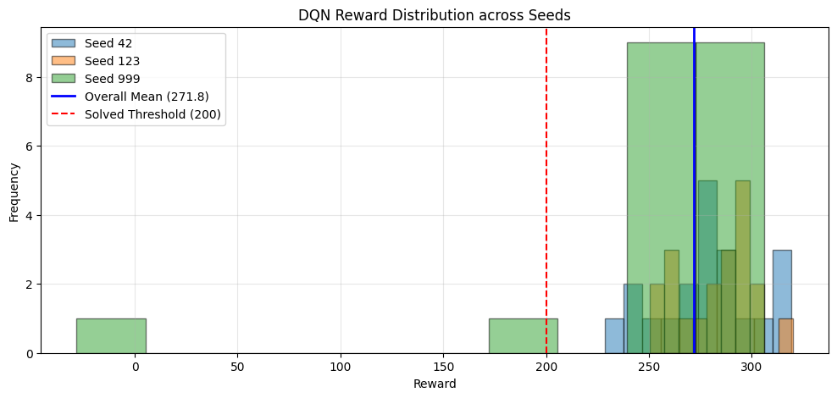

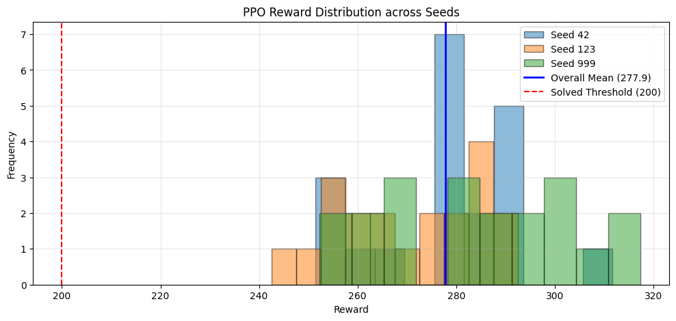

## Cross-Algorithm Comparison

# Cross-Algorithm: Combined Summary Table  
  
rows = []  
for algo_name in ALGORITHM_MAP:  
 all_r = np.concatenate([evaluation_results[algo_name][s] for s in SEED_LIST])  
 rows.append({  
 "Algorithm": algo_name.upper(),  
 "Mean Reward": f"{np.mean(all_r):.2f}",  
 "Std Dev": f"{np.std(all_r):.2f}",  
 "Min Reward": f"{np.min(all_r):.2f}",  
 "Max Reward": f"{np.max(all_r):.2f}",  
 "Success Rate": f"{(all_r >= 200).sum() / len(all_r) * 100:.1f}%"  
 })  
  
print(f"*** CROSS-ALGORITHM EVALUATION SUMMARY ***")  
print(f"Seeds: {SEED_LIST} | Episodes per seed: {EVALUATION_EPISODES}")  
print(f"Total episodes per algorithm: {EVALUATION_EPISODES * len(SEED_LIST)}")  
print()  
print(pd.DataFrame(rows).to_string(index=False))

*** CROSS-ALGORITHM EVALUATION SUMMARY ***  
Seeds: [42, 123, 999] | Episodes per seed: 20  
Total episodes per algorithm: 60  
  
Algorithm Mean Reward Std Dev Min Reward Max Reward Success Rate  
 DQN 271.80 45.14 -28.26 319.93 98.3%  
 PPO 277.86 16.87 242.53 317.36 100.0%

# Cross-Algorithm: Grouped Bar Chart (DQN vs PPO per seed)  
  
algo_names = list(ALGORITHM_MAP.keys())  
n_algos = len(algo_names)  
n_seeds = len(SEED_LIST)  
bar_width = 0.8 / n_algos  
x = np.arange(n_seeds)  
  
plt.figure(figsize=(max(10, 3 * n_seeds), 6))  
for i, algo_name in enumerate(algo_names):  
 means = [np.mean(evaluation_results[algo_name][s]) for s in SEED_LIST]  
 stds = [np.std(evaluation_results[algo_name][s]) for s in SEED_LIST]  
 offset = (i - (n_algos - 1) / 2) * bar_width  
 plt.bar(x + offset, means, bar_width, yerr=stds, capsize=4,  
 label=algo_name.upper(), alpha=0.8)  
  
plt.axhline(y=200, color='red', linestyle='--', label='Solved Threshold (200)')  
plt.xticks(x, [str(s) for s in SEED_LIST])  
plt.title(f"DQN vs PPO: Mean Reward per Seed ({EVALUATION_EPISODES} episodes each)", fontsize=14)  
plt.xlabel("Seed")  
plt.ylabel("Mean Reward")  
plt.legend()  
plt.grid(True, alpha=0.3, axis='y')  
plt.show()



# Cross-Algorithm: Overall Mean Reward Bar Chart  
  
algo_colors = {"dqn": "tab:blue", "ppo": "tab:orange"}  
  
overall_means = []  
overall_stds = []  
for algo_name in algo_names:  
 all_r = np.concatenate([evaluation_results[algo_name][s] for s in SEED_LIST])  
 overall_means.append(np.mean(all_r))  
 overall_stds.append(np.std(all_r))  
  
plt.figure(figsize=(8, 6))  
bars = plt.bar([a.upper() for a in algo_names], overall_means, yerr=overall_stds,  
 capsize=6, color=[algo_colors[a] for a in algo_names], alpha=0.8)  
plt.axhline(y=200, color='red', linestyle='--', label='Solved Threshold (200)')  
  
for bar, mean in zip(bars, overall_means):  
 plt.text(bar.get_x() + bar.get_width() / 2, bar.get_height() + 5,  
 f'{mean:.1f}', ha='center', va='bottom', fontweight='bold')  
  
plt.title(f"Overall Mean Reward: DQN vs PPO ({EVALUATION_EPISODES * len(SEED_LIST)} episodes each)", fontsize=14)  
plt.ylabel("Mean Reward")  
plt.legend()  
plt.grid(True, alpha=0.3, axis='y')  
plt.show()

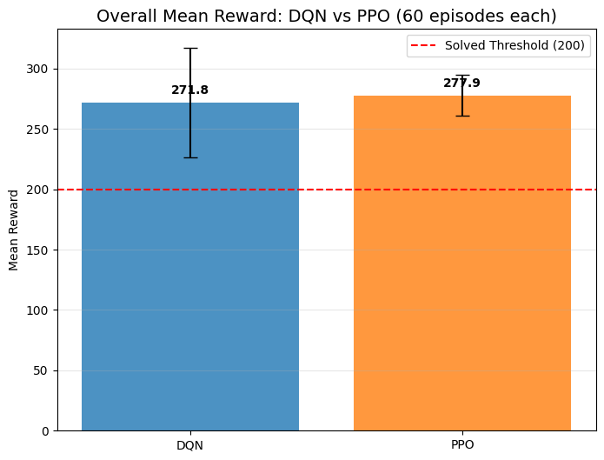

# Cross-Algorithm: Reward Distribution Comparison (overlaid histograms)  
  
plt.figure(figsize=(12, 5))  
for algo_name in algo_names:  
 all_r = np.concatenate([evaluation_results[algo_name][s] for s in SEED_LIST])  
 plt.hist(all_r, bins=15, alpha=0.5, color=algo_colors[algo_name],  
 edgecolor='black', label=f"{algo_name.upper()} (mean={np.mean(all_r):.1f})")  
  
plt.axvline(x=200, color='red', linestyle='--', label='Solved Threshold (200)')  
plt.title('Reward Distribution: DQN vs PPO (all seeds combined)', fontsize=14)  
plt.xlabel('Reward')  
plt.ylabel('Frequency')  
plt.legend()  
plt.grid(True, alpha=0.3)  
plt.show()

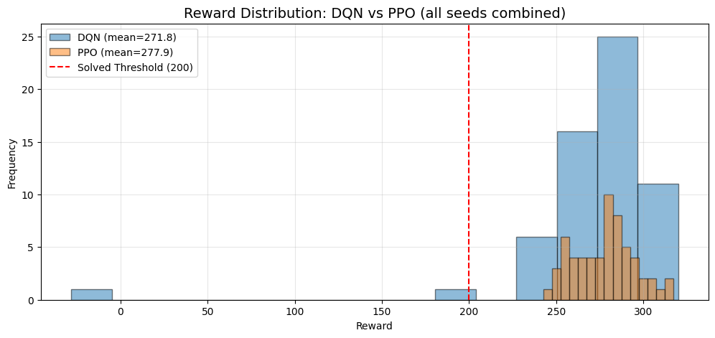

# Cross-Algorithm: Box Plot Comparison per Seed  
  
fig, axes = plt.subplots(1, len(SEED_LIST), figsize=(6 * len(SEED_LIST), 5), sharey=True)  
if len(SEED_LIST) == 1:  
 axes = [axes]  
  
for ax, seed in zip(axes, SEED_LIST):  
 data = [evaluation_results[algo_name][seed] for algo_name in algo_names]  
 bp = ax.boxplot(data, labels=[a.upper() for a in algo_names], patch_artist=True)  
 for patch, algo_name in zip(bp['boxes'], algo_names):  
 patch.set_facecolor(algo_colors[algo_name])  
 patch.set_alpha(0.6)  
 ax.axhline(y=200, color='red', linestyle='--')  
 ax.set_title(f"Seed {seed}")  
 ax.grid(True, alpha=0.3)  
  
axes[0].set_ylabel("Reward")  
fig.suptitle(f"DQN vs PPO: Reward Distribution per Seed ({EVALUATION_EPISODES} episodes each)", fontsize=14)  
plt.tight_layout()  
plt.show()

/tmp/ipykernel_86514/3208474440.py:9: MatplotlibDeprecationWarning: The 'labels' parameter of boxplot() has been renamed 'tick_labels' since Matplotlib 3.9; support for the old name will be dropped in 3.11.  
 bp = ax.boxplot(data, labels=[a.upper() for a in algo_names], patch_artist=True)  
/tmp/ipykernel_86514/3208474440.py:9: MatplotlibDeprecationWarning: The 'labels' parameter of boxplot() has been renamed 'tick_labels' since Matplotlib 3.9; support for the old name will be dropped in 3.11.  
 bp = ax.boxplot(data, labels=[a.upper() for a in algo_names], patch_artist=True)  
/tmp/ipykernel_86514/3208474440.py:9: MatplotlibDeprecationWarning: The 'labels' parameter of boxplot() has been renamed 'tick_labels' since Matplotlib 3.9; support for the old name will be dropped in 3.11.  
 bp = ax.boxplot(data, labels=[a.upper() for a in algo_names], patch_artist=True)

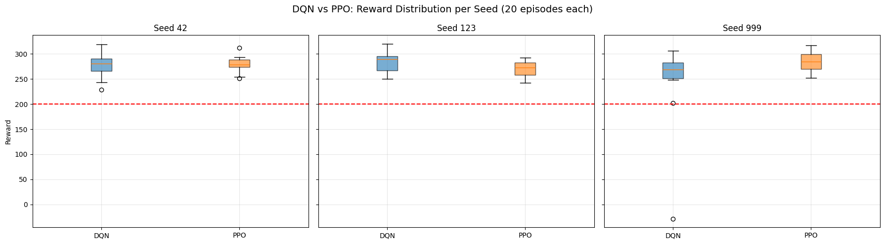

## Statistical Significance

# Statistical Significance: Mann-Whitney U Tests  
  
algo_names = list(ALGORITHM_MAP.keys())  
  
# Gather all rewards per algorithm  
algo_all_rewards = {}  
for algo_name in algo_names:  
 algo_all_rewards[algo_name] = np.concatenate([evaluation_results[algo_name][s] for s in SEED_LIST])  
  
# --- Reward comparison (Mann-Whitney U) ---  
mwu_result = stats.mannwhitneyu(  
 algo_all_rewards[algo_names[0]],  
 algo_all_rewards[algo_names[1]],  
 alternative='two-sided'  
)  
stat_reward = float(mwu_result.statistic)  
p_reward = float(mwu_result.pvalue)  
  
# --- Success rate comparison (Chi-squared) ---  
successes = []  
totals = []  
for algo_name in algo_names:  
 r = algo_all_rewards[algo_name]  
 successes.append(int((r >= 200).sum()))  
 totals.append(len(r))  
  
failures = [t - s for t, s in zip(totals, successes)]  
contingency = np.array([successes, failures])  
  
# Chi-squared requires all expected frequencies > 0; skip if any row/col is all-zero  
if np.all(contingency.sum(axis=1) > 0) and np.all(contingency.sum(axis=0) > 0):  
 chi2_result = stats.chi2_contingency(contingency)  
 chi2 = float(chi2_result[0]) # type: ignore[arg-type] # statistic  
 p_success = float(chi2_result[1]) # type: ignore[arg-type] # pvalue  
 chi2_valid = True  
else:  
 chi2, p_success = 0.0, 1.0  
 chi2_valid = False  
  
# --- Results table ---  
chi2_note = "" if chi2_valid else " (skipped: zero row/col)"  
rows = [  
 {  
 "Metric": "Mean Reward",  
 f"{algo_names[0].upper()} Value": f"{np.mean(algo_all_rewards[algo_names[0]]):.2f}",  
 f"{algo_names[1].upper()} Value": f"{np.mean(algo_all_rewards[algo_names[1]]):.2f}",  
 "Test": "Mann-Whitney U",  
 "Statistic": f"{stat_reward:.1f}",  
 "p-value": f"{p_reward:.4f}",  
 "Significant (p<0.05)": "Yes" if p_reward < 0.05 else "No"  
 },  
 {  
 "Metric": "Success Rate (>=200)",  
 f"{algo_names[0].upper()} Value": f"{successes[0]/totals[0]*100:.1f}%",  
 f"{algo_names[1].upper()} Value": f"{successes[1]/totals[1]*100:.1f}%",  
 "Test": f"Chi-squared{chi2_note}",  
 "Statistic": f"{chi2:.2f}",  
 "p-value": f"{p_success:.4f}",  
 "Significant (p<0.05)": "Yes" if (chi2_valid and p_success < 0.05) else "No"  
 },  
]  
  
print("*** STATISTICAL SIGNIFICANCE TESTS ***")  
print(f"Sample size per algorithm: {totals[0]} episodes ({EVALUATION_EPISODES} episodes x {len(SEED_LIST)} seeds)")  
print()  
print(pd.DataFrame(rows).to_string(index=False))  
print()  
if not chi2_valid:  
 print("Note: Chi-squared test skipped because one or both algorithms had 0% or 100% success rate.")  
 print(" This is expected during smoke tests with few episodes. Full run will have enough data.")  
 print()  
if p_reward < 0.05:  
 print(f"The reward difference between {algo_names[0].upper()} and {algo_names[1].upper()} is statistically significant (p={p_reward:.4f}).")  
else:  
 print(f"No statistically significant reward difference between {algo_names[0].upper()} and {algo_names[1].upper()} (p={p_reward:.4f}).")

*** STATISTICAL SIGNIFICANCE TESTS ***  
Sample size per algorithm: 60 episodes (20 episodes x 3 seeds)  
  
 Metric DQN Value PPO Value Test Statistic p-value Significant (p<0.05)  
 Mean Reward 271.80 277.86 Mann-Whitney U 1780.0 0.9185 No  
Success Rate (>=200) 98.3% 100.0% Chi-squared 0.00 1.0000 No  
  
No statistically significant reward difference between DQN and PPO (p=0.9185).

## Baseline Comparison

# Random Agent Baseline Evaluation  
  
random_results = {}  
  
for seed in SEED_LIST:  
 print(f"Running random agent with seed {seed}...")  
 env = gym.make(GYMNASIUM_MODEL, enable_wind=WIND_ENABLED)  
 env.action_space.seed(seed)  
 episode_rewards = []  
  
 for ep in range(EVALUATION_EPISODES):  
 obs, info = env.reset(seed=seed + ep)  
 total_reward = 0.0  
 done = False  
  
 while not done:  
 action = env.action_space.sample()  
 obs, reward, terminated, truncated, info = env.step(action)  
 total_reward += float(reward)  
 done = terminated or truncated  
  
 episode_rewards.append(total_reward)  
  
 random_results[seed] = np.array(episode_rewards)  
 env.close()  
  
print("Random baseline evaluation complete.")

Running random agent with seed 42...  
Running random agent with seed 123...  
Running random agent with seed 999...  
Random baseline evaluation complete.

# Baseline Comparison: Table + Chart  
  
algo_names = list(ALGORITHM_MAP.keys())  
algo_colors = {"dqn": "tab:blue", "ppo": "tab:orange"}  
algo_all_rewards = {a: np.concatenate([evaluation_results[a][s] for s in SEED_LIST]) for a in algo_names}  
  
all_random = np.concatenate([random_results[s] for s in SEED_LIST])  
  
rows = [  
 {  
 "Agent": "Random",  
 "Mean Reward": f"{np.mean(all_random):.2f}",  
 "Std Dev": f"{np.std(all_random):.2f}",  
 "Min": f"{np.min(all_random):.2f}",  
 "Max": f"{np.max(all_random):.2f}",  
 "Success Rate": f"{(all_random >= 200).sum() / len(all_random) * 100:.1f}%"  
 }  
]  
for algo_name in algo_names:  
 all_r = algo_all_rewards[algo_name]  
 rows.append({  
 "Agent": algo_name.upper(),  
 "Mean Reward": f"{np.mean(all_r):.2f}",  
 "Std Dev": f"{np.std(all_r):.2f}",  
 "Min": f"{np.min(all_r):.2f}",  
 "Max": f"{np.max(all_r):.2f}",  
 "Success Rate": f"{(all_r >= 200).sum() / len(all_r) * 100:.1f}%"  
 })  
rows.append({  
 "Agent": "Human (ref)",  
 "Mean Reward": "~200-300",  
 "Std Dev": "-",  
 "Min": "-",  
 "Max": "-",  
 "Success Rate": "~100%"  
})  
  
print("*** BASELINE COMPARISON ***")  
print(pd.DataFrame(rows).to_string(index=False))  
print()  
  
# Bar chart  
agent_labels = ["Random"] + [a.upper() for a in algo_names]  
agent_means = [np.mean(all_random)] + [np.mean(algo_all_rewards[a]) for a in algo_names]  
agent_stds = [np.std(all_random)] + [np.std(algo_all_rewards[a]) for a in algo_names]  
bar_colors = ["gray"] + [algo_colors[a] for a in algo_names]  
  
plt.figure(figsize=(10, 6))  
bars = plt.bar(agent_labels, agent_means, yerr=agent_stds, capsize=6,  
 color=bar_colors, alpha=0.8)  
plt.axhline(y=200, color='red', linestyle='--', label='Solved Threshold (200)')  
  
for bar, mean in zip(bars, agent_means):  
 plt.text(bar.get_x() + bar.get_width() / 2, bar.get_height() + 5,  
 f'{mean:.1f}', ha='center', va='bottom', fontweight='bold')  
  
plt.title(f"Baseline Comparison: Random vs DQN vs PPO ({EVALUATION_EPISODES * len(SEED_LIST)} episodes each)", fontsize=14)  
plt.ylabel("Mean Reward")  
plt.legend()  
plt.grid(True, alpha=0.3, axis='y')  
plt.show()

*** BASELINE COMPARISON ***  
 Agent Mean Reward Std Dev Min Max Success Rate  
 Random -205.65 109.48 -420.28 15.45 0.0%  
 DQN 271.80 45.14 -28.26 319.93 98.3%  
 PPO 277.86 16.87 242.53 317.36 100.0%  
Human (ref) ~200-300 - - - ~100%

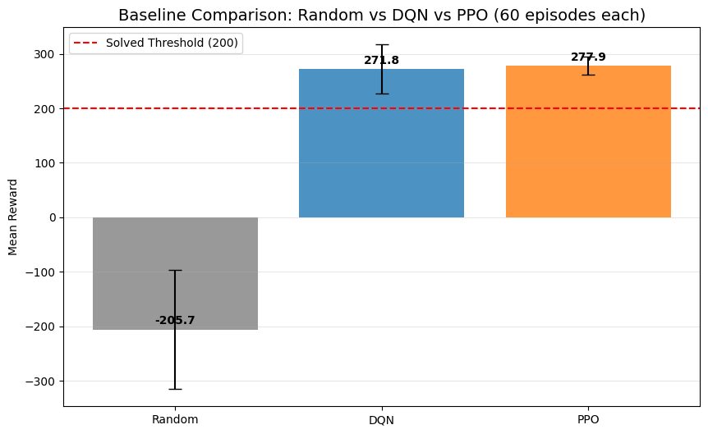

## Agent Behavior Analysis

# Collect per-step data: actions and trajectories  
  
action_counts = {} # {algo: np.array of shape (4,)} total action counts  
trajectory_data = {} # {algo: list of (x_positions, y_positions)} one per TRAJECTORY_EPISODES  
  
for algo_name, algo_class in ALGORITHM_MAP.items():  
 action_counts[algo_name] = np.zeros(len(ACTION_LABELS), dtype=int)  
 trajectory_data[algo_name] = []  
  
 for seed in SEED_LIST:  
 load_path = best_model_paths.get(algo_name, {}).get(seed)  
 if load_path is None:  
 continue  
  
 def make_env(s=seed):  
 env = gym.make(GYMNASIUM_MODEL, render_mode="rgb_array", enable_wind=WIND_ENABLED)  
 env.reset(seed=s)  
 return env  
  
 model = algo_class.load(load_path, env=DummyVecEnv([make_env]), device=DEVICE)  
 env = gym.make(GYMNASIUM_MODEL, enable_wind=WIND_ENABLED)  
  
 for ep in range(EVALUATION_EPISODES):  
 obs, info = env.reset(seed=seed + ep)  
 done = False  
 x_pos, y_pos = [obs[0]], [obs[1]]  
  
 while not done:  
 action, _ = model.predict(obs, deterministic=True)  
 action_int = int(action)  
 action_counts[algo_name][action_int] += 1  
  
 obs, reward, terminated, truncated, info = env.step(action)  
 done = terminated or truncated  
 x_pos.append(obs[0])  
 y_pos.append(obs[1])  
  
 # Keep trajectory for the first TRAJECTORY_EPISODES episodes of the first seed  
 if seed == SEED_LIST[0] and ep < TRAJECTORY_EPISODES:  
 trajectory_data[algo_name].append((np.array(x_pos), np.array(y_pos)))  
  
 env.close()  
  
 total_actions = action_counts[algo_name].sum()  
 print(f"{algo_name.upper()}: {total_actions:,} total actions collected across {EVALUATION_EPISODES * len(SEED_LIST)} episodes")  
  
print("\nBehavior data collection complete.")

DQN: 17,103 total actions collected across 60 episodes  
PPO: 15,857 total actions collected across 60 episodes  
  
Behavior data collection complete.

# Action Distribution: DQN vs PPO  
  
n_actions = len(ACTION_LABELS)  
x = np.arange(n_actions)  
bar_width = 0.35  
  
fig, (ax1, ax2) = plt.subplots(1, 2, figsize=(16, 6))  
  
# Absolute counts  
for i, algo_name in enumerate(algo_names):  
 offset = (i - 0.5) * bar_width  
 ax1.bar(x + offset, action_counts[algo_name], bar_width,  
 label=algo_name.upper(), color=algo_colors[algo_name], alpha=0.8)  
  
ax1.set_xticks(x)  
ax1.set_xticklabels(ACTION_LABELS, rotation=15)  
ax1.set_title("Action Counts (Absolute)", fontsize=13)  
ax1.set_ylabel("Count")  
ax1.legend()  
ax1.grid(True, alpha=0.3, axis='y')  
  
# Percentage distribution  
for i, algo_name in enumerate(algo_names):  
 pcts = action_counts[algo_name] / action_counts[algo_name].sum() * 100  
 offset = (i - 0.5) * bar_width  
 bars = ax2.bar(x + offset, pcts, bar_width,  
 label=algo_name.upper(), color=algo_colors[algo_name], alpha=0.8)  
 for bar, pct in zip(bars, pcts):  
 ax2.text(bar.get_x() + bar.get_width() / 2, bar.get_height() + 0.5,  
 f'{pct:.1f}%', ha='center', va='bottom', fontsize=9)  
  
ax2.set_xticks(x)  
ax2.set_xticklabels(ACTION_LABELS, rotation=15)  
ax2.set_title("Action Distribution (Percentage)", fontsize=13)  
ax2.set_ylabel("Percentage (%)")  
ax2.legend()  
ax2.grid(True, alpha=0.3, axis='y')  
  
fig.suptitle(f"DQN vs PPO: Action Distribution ({EVALUATION_EPISODES * len(SEED_LIST)} episodes each)", fontsize=14)  
plt.tight_layout()  
plt.show()

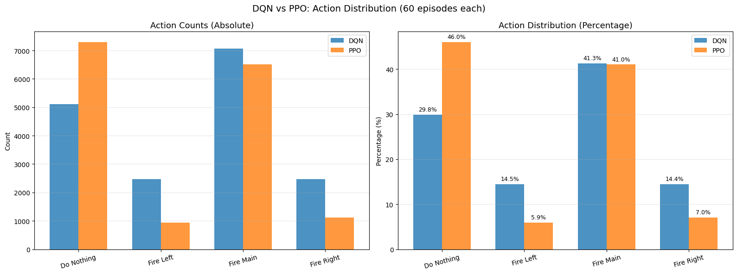

# Trajectory Plots: x-y paths of the lander  
  
fig, axes = plt.subplots(1, len(algo_names), figsize=(8 * len(algo_names), 6), sharey=True)  
if len(algo_names) == 1:  
 axes = [axes]  
  
traj_colors = list(plt.colormaps["Set2"](range(8))) # type: ignore[arg-type]  
  
for ax, algo_name in zip(axes, algo_names):  
 for i, (x_pos, y_pos) in enumerate(trajectory_data[algo_name]):  
 ax.plot(x_pos, y_pos, color=traj_colors[i], linewidth=1.5, alpha=0.8,  
 label=f"Episode {i+1}")  
 ax.scatter(x_pos[0], y_pos[0], color=traj_colors[i], marker='o', s=60, zorder=5)  
 ax.scatter(x_pos[-1], y_pos[-1], color=traj_colors[i], marker='x', s=80, zorder=5)  
  
 # Landing pad reference  
 ax.axhline(y=0, color='black', linestyle='-', linewidth=0.5, alpha=0.3)  
 ax.axvline(x=0, color='black', linestyle='-', linewidth=0.5, alpha=0.3)  
 ax.scatter(0, 0, color='red', marker='^', s=120, zorder=10, label='Landing Pad')  
  
 ax.set_title(f"{algo_name.upper()} Trajectories (seed {SEED_LIST[0]})", fontsize=13)  
 ax.set_xlabel("X Position")  
 ax.legend(fontsize=9)  
 ax.grid(True, alpha=0.3)  
  
axes[0].set_ylabel("Y Position")  
fig.suptitle(f"Lander Trajectories: DQN vs PPO ({TRAJECTORY_EPISODES} episodes each)", fontsize=14)  
plt.tight_layout()  
plt.show()

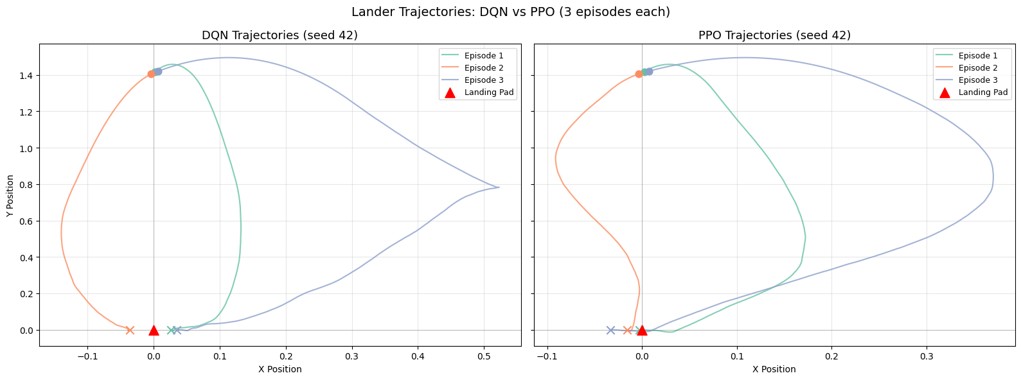

# Trajectory Comparison: DQN vs PPO overlaid on one chart  
  
plt.figure(figsize=(10, 7))  
  
for algo_name in algo_names:  
 # Plot the first trajectory from each algorithm  
 x_pos, y_pos = trajectory_data[algo_name][0]  
 plt.plot(x_pos, y_pos, color=algo_colors[algo_name], linewidth=2, alpha=0.8,  
 label=f"{algo_name.upper()}")  
 plt.scatter(x_pos[0], y_pos[0], color=algo_colors[algo_name], marker='o', s=80, zorder=5)  
 plt.scatter(x_pos[-1], y_pos[-1], color=algo_colors[algo_name], marker='x', s=100, zorder=5)  
  
plt.scatter(0, 0, color='red', marker='^', s=150, zorder=10, label='Landing Pad')  
plt.axhline(y=0, color='black', linestyle='-', linewidth=0.5, alpha=0.3)  
plt.axvline(x=0, color='black', linestyle='-', linewidth=0.5, alpha=0.3)  
  
plt.title(f"DQN vs PPO: Landing Trajectory Comparison (seed {SEED_LIST[0]}, episode 1)", fontsize=14)  
plt.xlabel("X Position")  
plt.ylabel("Y Position")  
plt.legend(fontsize=11)  
plt.grid(True, alpha=0.3)  
plt.show()

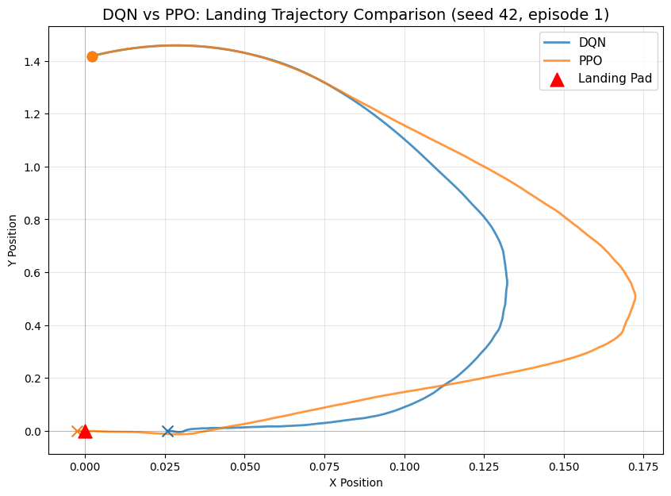

## GIF Visualizations

# GIF Visualizations (one per algorithm per seed, best model)  
  
for algo_name, algo_class in ALGORITHM_MAP.items():  
 output_dir = os.path.join(NOTEBOOK_DIR, "outputs_" + algo_name)  
 os.makedirs(output_dir, exist_ok=True)  
  
 for seed in SEED_LIST:  
 load_path = best_model_paths.get(algo_name, {}).get(seed)  
 if load_path is None:  
 print(f"SKIPPING GIF for {algo_name.upper()} seed {seed} — best model not found")  
 continue  
  
 print(f"Generating GIF for {algo_name.upper()} seed {seed} (best model)...")  
  
 def make_vis_env(s=seed):  
 env = gym.make(GYMNASIUM_MODEL, render_mode="rgb_array", enable_wind=WIND_ENABLED)  
 env.reset(seed=s)  
 return env  
  
 vis_model = algo_class.load(load_path, env=DummyVecEnv([make_vis_env]), device=DEVICE)  
  
 vis_env = gym.make(GYMNASIUM_MODEL, render_mode="rgb_array", enable_wind=WIND_ENABLED)  
 frames = []  
 obs, info = vis_env.reset(seed=seed)  
 done = False  
  
 while not done:  
 action, _ = vis_model.predict(obs, deterministic=True)  
 obs, reward, terminated, truncated, info = vis_env.step(action)  
 done = terminated or truncated  
 frames.append(vis_env.render())  
  
 vis_env.close()  
  
 gif_path = os.path.join(output_dir, f"{algo_name}_seed{seed}.gif")  
 imageio.mimsave(gif_path, frames, fps=30)  
 print(f" Saved: {gif_path}")  
 display(Image(filename=gif_path))

Generating GIF for DQN seed 42 (best model)...  
 Saved: /home/logus/env/iscte/taap_p2/drafts/draft_01/gymnasium/outputs_dqn/dqn_seed42.gif  
  
  
  
<IPython.core.display.Image object>  
  
  
Generating GIF for DQN seed 123 (best model)...  
 Saved: /home/logus/env/iscte/taap_p2/drafts/draft_01/gymnasium/outputs_dqn/dqn_seed123.gif  
  
  
  
<IPython.core.display.Image object>  
  
  
Generating GIF for DQN seed 999 (best model)...  
 Saved: /home/logus/env/iscte/taap_p2/drafts/draft_01/gymnasium/outputs_dqn/dqn_seed999.gif  
  
  
  
<IPython.core.display.Image object>  
  
  
Generating GIF for PPO seed 42 (best model)...  
 Saved: /home/logus/env/iscte/taap_p2/drafts/draft_01/gymnasium/outputs_ppo/ppo_seed42.gif  
  
  
  
<IPython.core.display.Image object>  
  
  
Generating GIF for PPO seed 123 (best model)...  
 Saved: /home/logus/env/iscte/taap_p2/drafts/draft_01/gymnasium/outputs_ppo/ppo_seed123.gif  
  
  
  
<IPython.core.display.Image object>  
  
  
Generating GIF for PPO seed 999 (best model)...  
 Saved: /home/logus/env/iscte/taap_p2/drafts/draft_01/gymnasium/outputs_ppo/ppo_seed999.gif  
  
  
  
<IPython.core.display.Image object>

## Appendix: Experimental Setup

### Environment Details

| **Property** | **Value** |
| --- | --- |
| Environment | LunarLander-v3 (Gymnasium) |
| Observation Space | Box(8,) — continuous 8-dimensional vector |
| Action Space | Discrete(4) — do nothing, fire left, fire main, fire right |
| Solved Threshold | Mean reward >= 200 over 100 consecutive episodes |
| Wind | Disabled (enable_wind=False) |

**Observation vector:** [x, y, vx, vy, angle, angular_velocity, left_leg_contact, right_leg_contact]

**Reward structure:** - Moving toward the landing pad: positive - Moving away: negative - Crash: -100 - Successful landing: +100 - Each leg ground contact: +10 - Firing main engine: -0.3 per frame - Firing side engine: -0.03 per frame

**Termination rules:** - **Terminated (success):** The lander comes to rest on the ground with both legs in contact, near-zero velocity - **Terminated (crash):** The lander body contacts the ground, or the lander moves outside the viewport boundaries - **Truncated (timeout):** The episode exceeds 1000 timesteps without termination

# Environment inspection  
  
env_tmp = gym.make(GYMNASIUM_MODEL, enable_wind=WIND_ENABLED)  
print(f"Environment: {GYMNASIUM_MODEL}")  
print(f"Observation space: {env_tmp.observation_space}")  
print(f"Action space: {env_tmp.action_space}")  
print(f"Wind enabled: {WIND_ENABLED}")  
  
obs, info = env_tmp.reset(seed=42)  
print(f"\nSample observation: {obs}")  
print(f"Observation labels: [x, y, vx, vy, angle, angular_vel, left_leg, right_leg]")  
env_tmp.close()

Environment: LunarLander-v3  
Observation space: Box([ -2.5 -2.5 -10. -10. -6.2831855 -10.  
 -0. -0. ], [ 2.5 2.5 10. 10. 6.2831855 10.  
 1. 1. ], (8,), float32)  
Action space: Discrete(4)  
Wind enabled: False  
  
Sample observation: [ 0.00229702 1.4181306 0.2326471 0.3204666 -0.00265488 -0.05269805  
 0. 0. ]  
Observation labels: [x, y, vx, vy, angle, angular_vel, left_leg, right_leg]

# System and library versions  
  
import stable_baselines3  
  
print(f"Python: {sys.version.split()[0]}")  
print(f"PyTorch: {torch.__version__}")  
print(f"Stable-Baselines3: {stable_baselines3.__version__}")  
print(f"Gymnasium: {gym.__version__}")  
print(f"NumPy: {np.__version__}")  
print(f"Device: {DEVICE}")  
print(f"CUDA: {torch.version.cuda if torch.cuda.is_available() else 'Not available'}")

Python: 3.12.3  
PyTorch: 2.10.0+cu130  
Stable-Baselines3: 2.7.1  
Gymnasium: 1.2.3  
NumPy: 2.4.2  
Device: cpu  
CUDA: 13.0